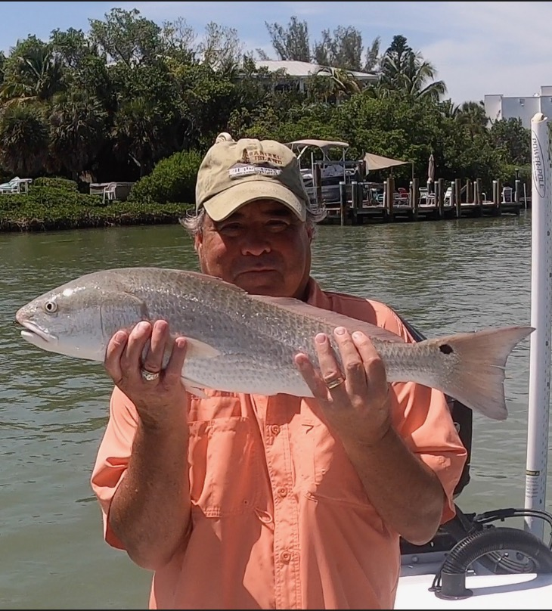

Pic: Vince Nowell of Sanibel with a redfish he caught with Capt Matt Mitchell this week

Go deep in hot water conditions

As we move into July I just don’t recall our water temperature being so extremely hot this early in the summer as it’s at a bath like 90 degrees plus. We need our normal summer afternoon rain pattern to get into full swing to help cool things off. Getting out early before the heat of the day anglers will find the best action in the first few hours after sunrise.

Deeper water in and around the passes is a little cooler as it does not get as hot as the shallow flats. This week I spent most of my time fishing the western side of the sound around the passes and out along the beaches. Sight fishing snook and trout on any kind of down structure along the beaches was great morning action. During periods of east winds or light winds these beaches offer some nonstop action all summer long.

Keeping bait fish alive all day has been tough going as surface water temperature has to be reaching into the mid 90’s by mid afternoon. On days we have been running doubles we have begun keeping back up bait in holding pens sunk in deeper water so its lively for our afternoon trips. Keeping cut bait onboard is also a good call to give you a option if everything poaches and goes belly up in the live well.

Drifting the passes has been the best action for me this week with the outgoing tide bite being on fire at times. Having 20 plus boats all drifting the pass looks out of control at times though when everybody follows the program you will see everyone catch fish. All it takes is one boat doing it differently and it messes up for everyone, don’t be that guy. Often there is only one hot section of the drift where the fish are biting. Making the full drift is the correct way to do it while taking your place in line. Use live pinfish and grunts with enough weight to hit the bottom and hold on tight.

Tarpon continue to be in better numbers at the northern end of the sound. Fosters point on North Captiva was one of the hot spots this week. Getting there early and being able to pitch live baits at these fish has paid off before its is over run with boats spooking the fish. Crabs, pinfish and threadfin herring have been the baits of choice. Often it’s just getting a bait to these fish to get that hook up.

