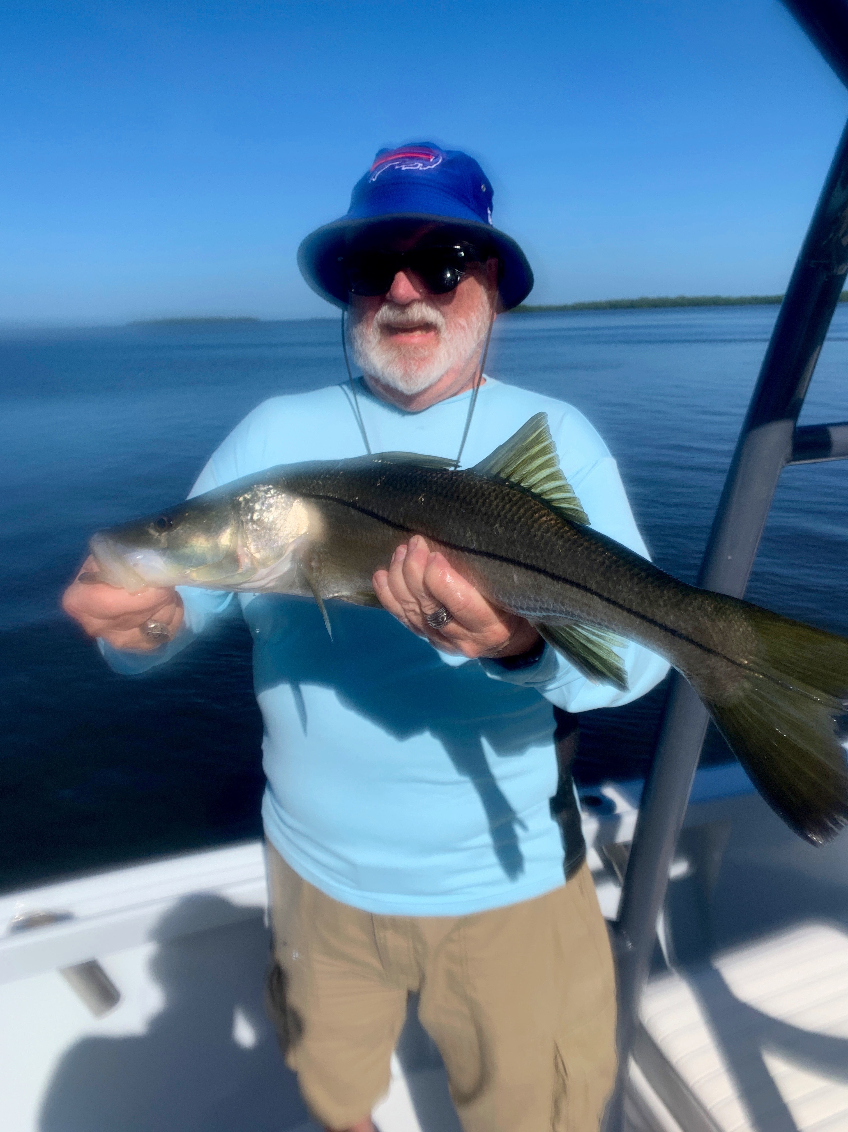

Get the cold weather gear out again.

Pic: Bigger snook where more common this week as water temperatures reached the mid 70’s

After almost a full week of 70 degree plus warm water snook fishing the strongest cold front of this winter is forecast to arrive. So far this January we have only had a few very brief cold snaps and have been setting record high temperatures with many days reaching into the 80’s. Cast netting shiners to snook fish in mid January is just not a normal winter for us. While fishing around redfish pass this week I saw hundreds of snook over the shallows while targeting sheepshead on docks, its usually one species or the other.

Cold fronts are just a normal part of our winter fishing though the up and down temperatures can make working out a pattern a little tough. A few rules of thumb this time of year are that 70 degrees water temperature is the tipping point. At 70 degree’s or above shiner fish and when its below 70 degrees, shrimp fish. The colder the water the smaller and slower I fish the bait. During the coldest periods a chunk of shrimp threaded on a jig head will catch fish when nothing else will.

Snook fishing was outstanding this week with some amazing action fishing close to home in and around St James city. Clients caught and released fish up to 30 inches on several trips along with quite a few redfish. Pitching live shiners was the method of choice on deeper mangrove shorelines with moving tide. Many of the small cuts between mangroves islands that had the faster current where are hot spots.

Clients looking for food fish will do much better after this next cold front as the sheepshead fishing has ground to a slow halt with warming water temperatures. We did catch a few really large sheepshead this week though in the warmer water its hard to keep a shrimp on a hook around docks as a wide variety of other smaller species steal it. We did find a pretty solid black drum bite this week with fish between 18-24 inches being extremely common.

Though trout remains closed the action is getting more and more consistent with lots of bigger trout being caught around the St James hump and Picnic Island. The old standby of live shrimp under a popping cork was hard to beat for these trout. Many of these trout measured between 18-22 inches and made completing the “Pine Island Slam” easier than it has been.

With the next 10 days of weather not forecast to get out of the mid 70’s water temperatures are going to drop drastically. February is always one of our best months for sheepshead fishing and this should hold true. Expect the biggest wave yet of winter pre spawn sheepshead of to push into the sound as we see low 60’s for water temperatures. Being able to go fishing with just live shrimp and come home with dinner is never a bad thing.

