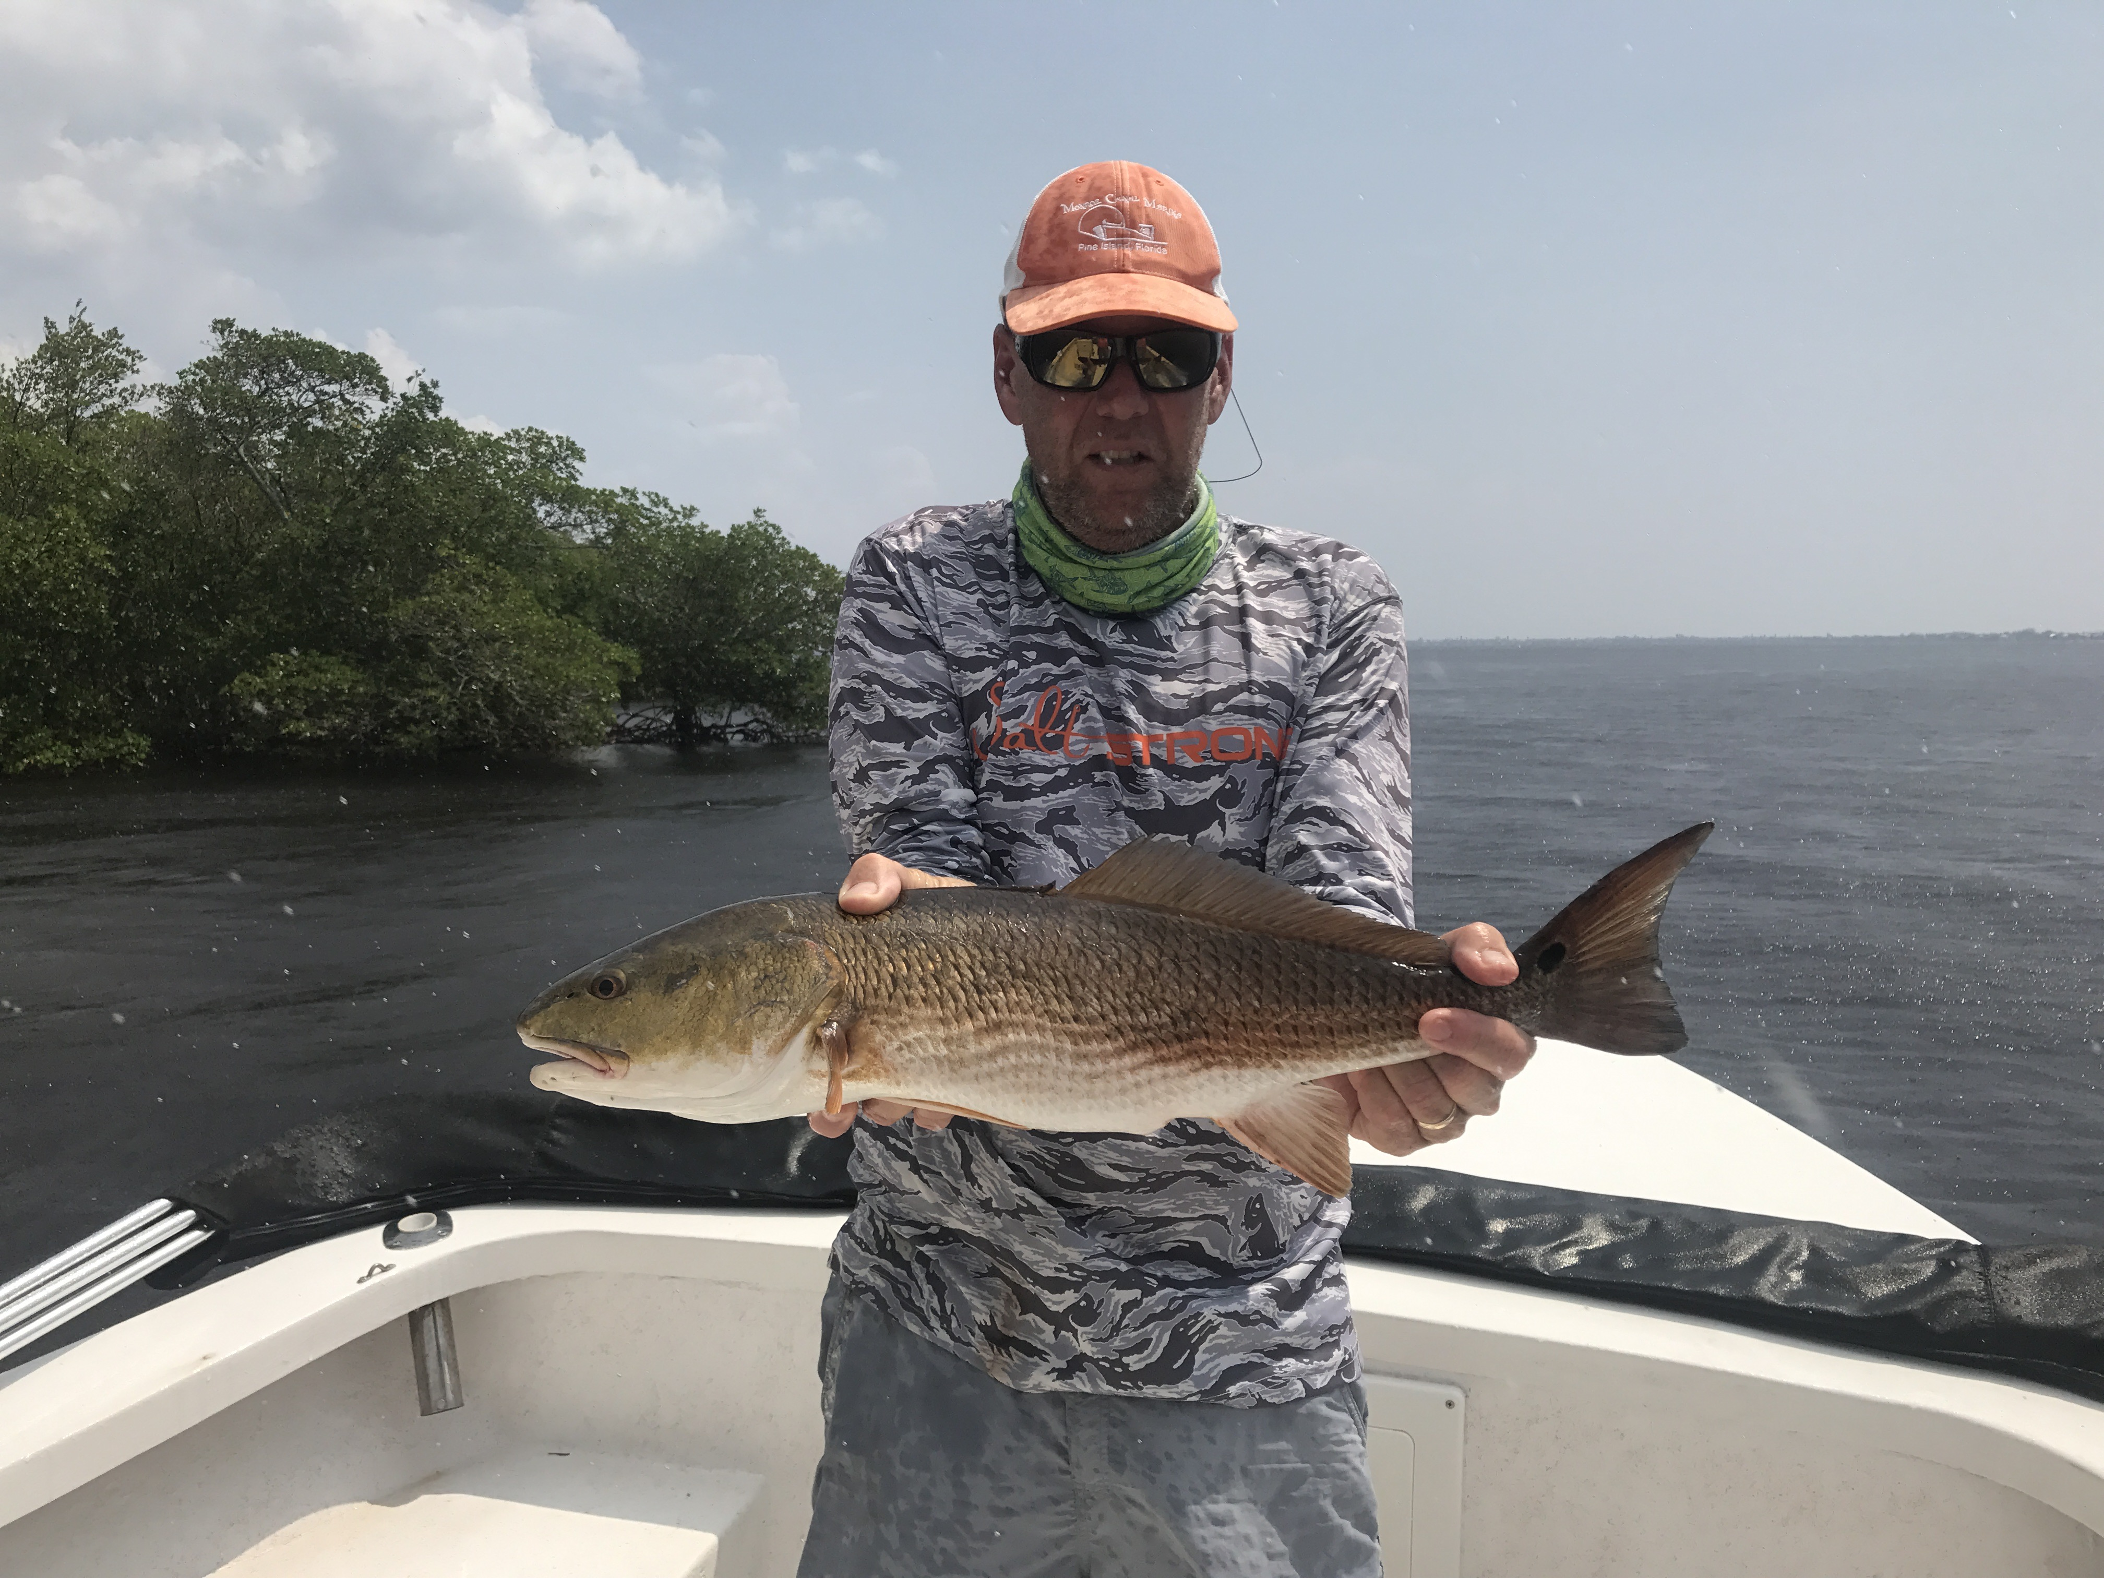

Get out of your comfort zone

Picture: Enjoying a day off scouting Redfish

East winds for almost two weeks have done wonders for pushing the majority of the red tide out of the sound. Sure In places close to the passes you will still find a few dead fish floating around although it’s getting noticeably less and less everyday. Looking at the FWC red tide chart the sound is still experiencing low levels of red tide while Matlacha pass all the way up to the Mayakka river is still red tide free as it has been for the last month.

If there is any positive note at all from this extreme supercharged red tide it’s that it has made me learn to fish areas that I just never go. Over the past few decades on the water I very seldom fish the middle to northern end of Matlacha pass as I just can’t seem to find consistent fishing here. This whole area see’s very little angler pressure due to how long of a run it is and the fact the majority of the water once you leave the marked channel is a year round slow speed zone. Most of my time on the water this week was spent here from Hell’s Gate, which is north of Tropical home sites all the way up to Smokehouse bay, which is by Bokeeiia. This long stretch of water offers anglers an almost untouched fishery.

The amount of sea life that has been pushed into this summer Black water area is amazing. This area of water, which is free of red tide, has been producing a great mixed bag of fish including Trout, Snook, Redfish and even Tarpon. Taking what you know about fishing from the sound and taking it to new water involves a learning curve and when everything does line up and you get it right its really satisfying. For those of you that are not familiar with Matlacha pass it’s a very unforgiving place to fish with lots of hard shell bottom and oyster bars. The summer black water makes here make it hard to visually see these oyster bars and obstructions.

Matlacha pass also has lots of healthy grass flats and miles of almost un fished mangrove shorelines. With almost all the water out of the marked channel being slow speed zones this area just makes you slow down and really think out what your next move is and where your going to fish. Area’s north of the bridge have had lots of feeding birds that are over trout and Ladyfish along with a few rolling Tarpon. On wind blown deeper mangrove shorelines and creek mouths on either side of the bridge I caught Snook and even tied into a few big Redfish. At the northern tip of Bokeelia at what is referred to as the 9/11 flat bait has also been plentiful. The more I fish this area the more I am beginning to like it even though it does not give up its secrets easily.

Getting out and fishing somewhere out of your comfort zone is a good thing. On way too many trips its just too easy to fish your usual spots and get in a rut even though these place offer almost guaranteed action. Sometimes it takes something like red tide to make you switch it up. There is just something satisfying as a angler to catch fish in places you have just never fished.

