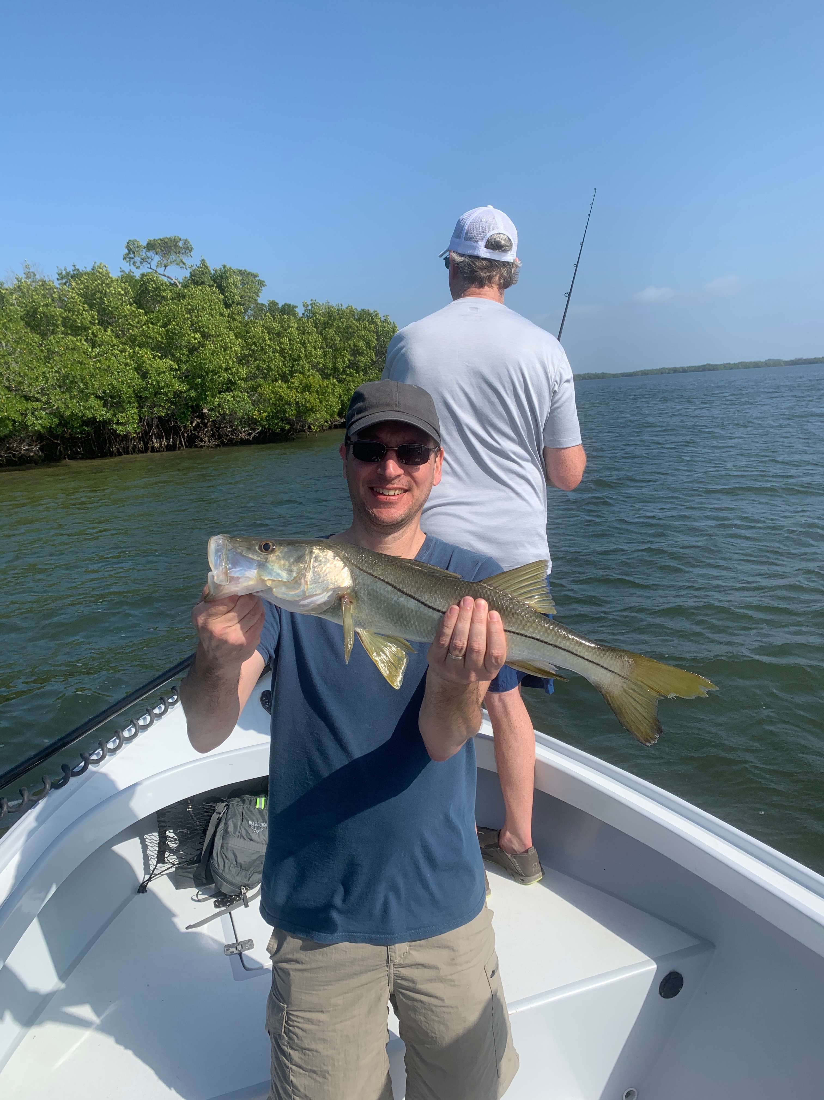

Fishing heats up

Pic: Tim from MN with a Snook caught while fishing with Capt Matt Mitchell this week.

Over the past few weeks, season in southwest Florida has kicked into high gear. This amazing stretch of weather we are experiencing over the past ten days is what winter in Florida is all about. Once away from the more travelled water ways there are plenty of places to get away from the crowds and catch fish while enjoying the tranquility that being with nature is all about.

Spring like weather in February though its a little unusual did wonders for our fishing. In less than one week our waters came to life as water temperatures rebounded more than 10 degrees and back into the low 70’s. Anglers quickly scrambled to switch patterns from the normal winter time shrimp fishing to shiner fishing. After a two week break from catching shiners my mornings are now starting as they do most of the year by throwing a cast net to catch bait on the flats. Once loaded with these magical baits Snook, redfish and big jack Crevalles kept the rods bent.

Although this warm up is bad news for sheepshead fisherman, it did not take me long to realize how much I had missed shiner fishing. Most of our grass flats are covered with birds diving on baitfish along with the mackerel, trout and ladyfish that are feeding on them. Seeing the bay come to life makes me feel like Spring has arrived early. What has happened in the past few years is that after a winter warming trend we get slammed by one or two more strong cold fronts in March or even early April.

Clients this week got to experience some of the most crazy wide open fishing I have seen in a long time. Chumming live shiners and have fish blow up everywhere is what our fishing is all about no matter what month it is.

