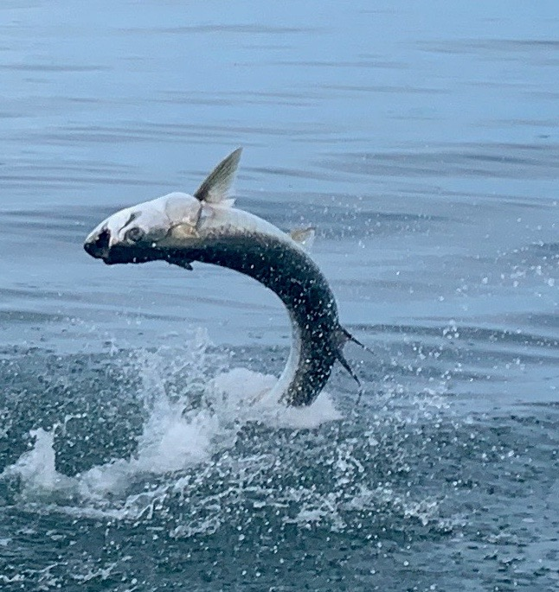

Find the Tarpon highway

Pic: Flying high

Finding tarpon proved relatively easy this week with lots of fish in the northern sound. The first few hours after day light as usual is the best time to locate and set up on these fish. For a few days we had extremely calm water and the number of fish showing in these areas was crazy though in these super slick conditions we saw very few hook ups. Pitching live baits to rolling fish and watching them circle around and even rollover your bait without eating was all part of the usual tarpon frustration.

While throwing crabs and pinfish out in front of rolling fish for over a hour early one morning this week I opted to cast a chunk of fresh cut mullet out the back of the boat. Within 5 minutes we were hooked up to a fish that just kept jumping without making any long runs. Tarpon battles with so many jumps are the ones we dream of as fishing guides. The more they jump the faster they wear themselves out and a 10-15-minute tarpon fight is as good as it gets for both the fish and the angler. Getting to see a tarpon jump within 30ft of the boat is not only great for photos but also something the client will never forget.

Most of the tarpon I’m finding are between Redfish pass and Cabbage key. This zone has been the most productive for me for the past few weeks. I did find a few fish between Sanibel and St James city too this week which appeared and disappeared within a few days. Most days i have been making the run north and spending my time sat in rolling fish for most of the morning. These tarpon move in and out of Captiva pass almost like clockwork and go north or south behind the barrier islands. Though many anglers like to chase them with a trolling motor I have been setting up on the anchor once I work out how they are traveling and letting them come to us.

Once you do locate tarpon spend some time watching how they are moving. Many times pod after pod will follow the same line or depth contour. Depending on the tide they can be either moving north or south. Once you get a better idea of how they are moving try to set up so you get the most traffic by your baits. If I’m throwing cut bait’s, I like to find an area with sand bottom or even a sand hole to set my baits in. Often I run cut baits out of the stern while having my clients pitch live baits out of the bow. Once you get set up in the tarpon highway stay put and its often just a matter of time before you get hit.

