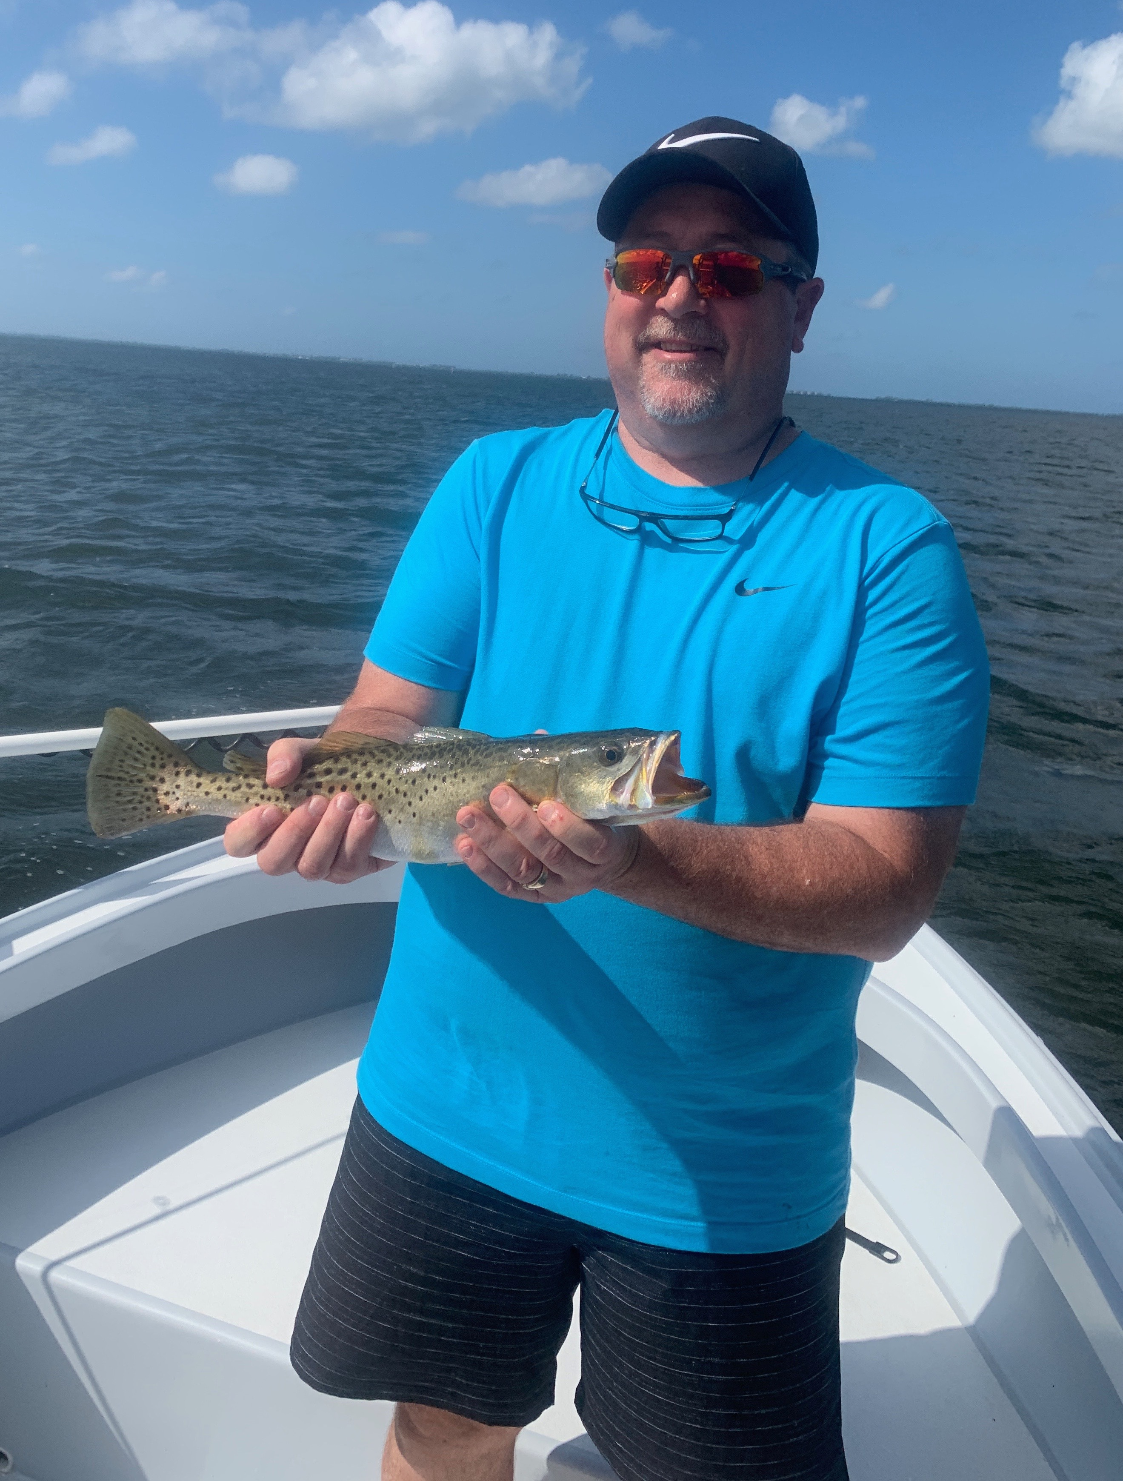

Pic: Phillip with one of many big trout we caught on his birthday fishing trip this week.

Fall fishing frenzy.

The amazing waters of Pine Island sound continue to be just full of life. Feeding birds and hungry fish are being found the entire length from lighthouse point all the way to Bokeelia. Strong prevailing NE winds this week so I concentrated my efforts on the calmer eastern side of the sound. Fishing any place with feeding birds brought a mixed bag of fish including, trout, snapper, jacks, bluefish and ladyfish just to name a few. This crazy wide open bite has to be experienced to be believed and for sheer numbers of fish cannot be beat.

My clients wanting to target redfish have been happy to though its been all about the tide to catch these fish. This redfish bite as usual has come during the higher water periods. Windy conditions all week made sight fishing the schools tough if not impossible so its been a matter of working the mangroves and oyster bars. Our redfish bite this week came from Mason key south to Clam key. Picking away at the wind blown shorelines with both fresh cut ladyfish and tail hooked pinfish we caught redfish after redfish up to 26 inches. Once you found a hot spot often it would hold 3-5 fish then it was time to move again.

My days on the water have played out the same way with us catching the easy fish on the feeding birds and giving my clients lots of action. This has generally included a mangrove snapper dinner while waiting on the tide to get high enough to redfish. Other options on the lower water have been in the passes for Snook and redfish though once the tide gets moving the water has been just to fast and its all been over. Riding the tower in the passes its amazing how many big snook and redfish I’m seeing though most of the time these fish are just not feeding for me.

Now that are winds have finally started to lay down flats on the inside of the passes are a great place to look for schools of redfish. Mid September till Mid November are prime time for these hungry charging bull reds to pop up. On shallow water flats these fish are easy to locate as they churn up the water with birds feeding close to the water on the bait spraying to get out of the way. Basically any long casting bait or artificial will catch these fish. A weedless 1/2oz spoon or chunk of cut bait can be thrown a mile and does not hang much grass in the shallow water.

