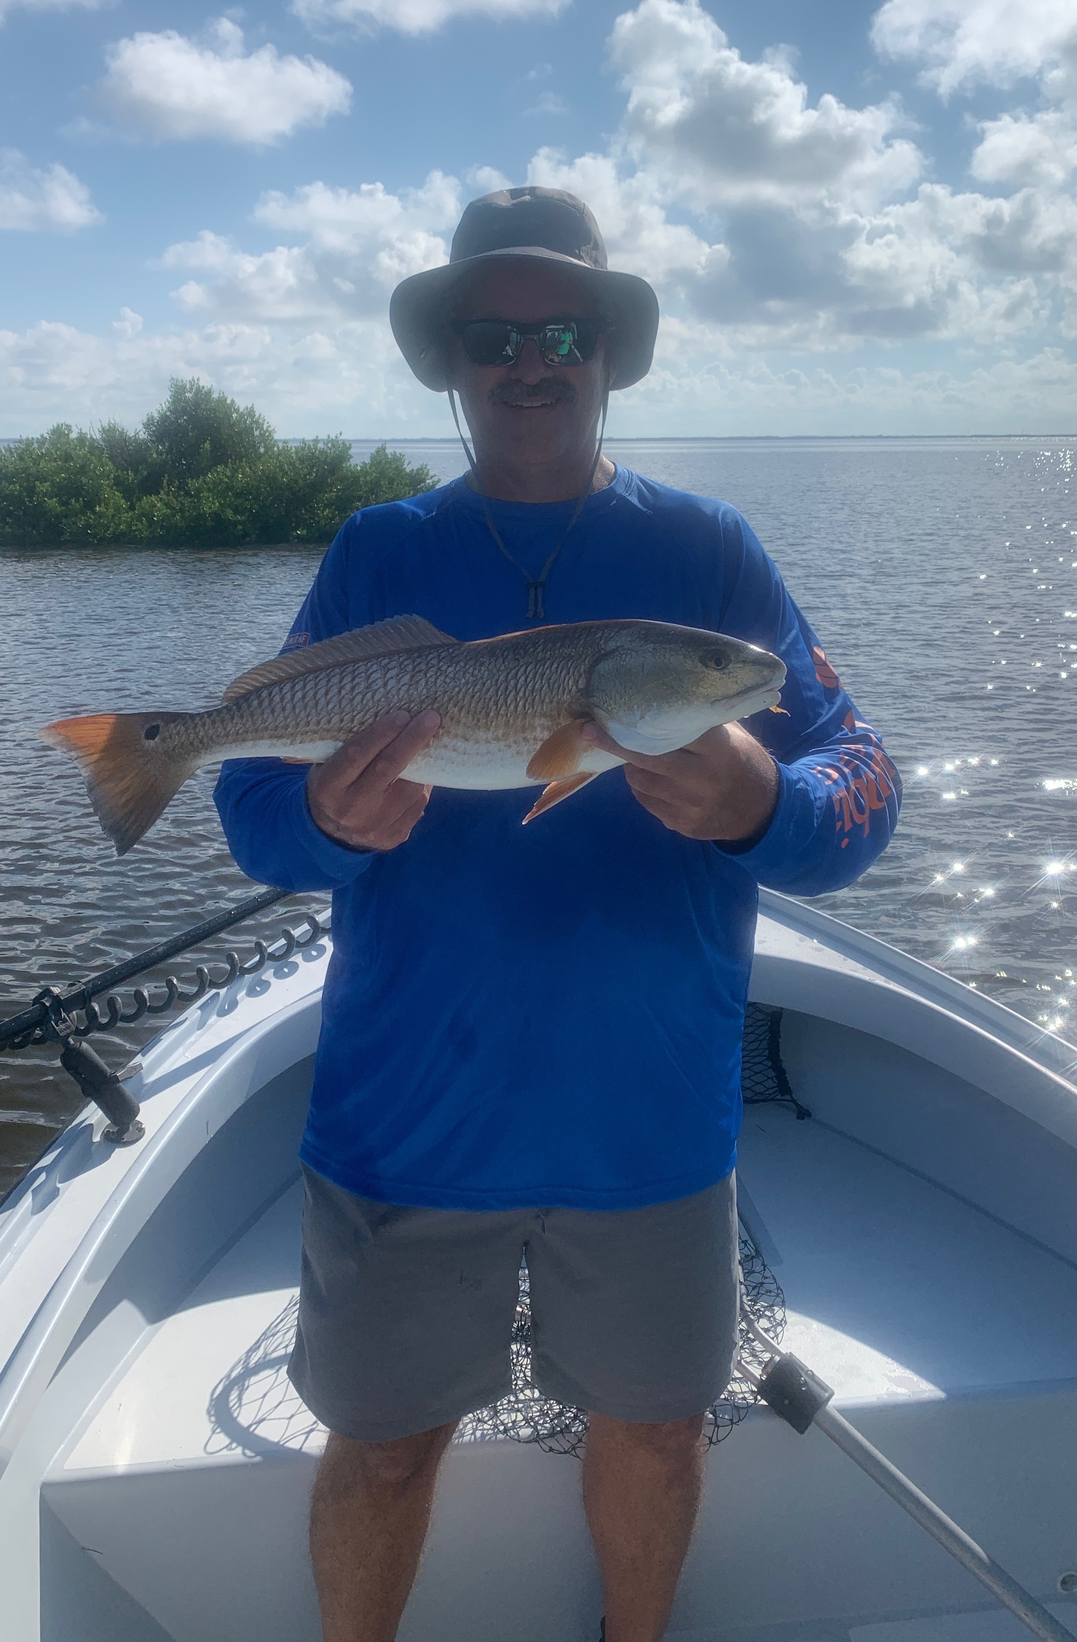

Fabulous Fall fishing.

Pic: Mike from Cape Coral with a Redfish caught oyster bar fishing with Capt Matt Mitchell this week

Signs of Fall although very subtle have begun. A couple of cooler less humid mornings were a nice break and a sure sign the oppressive heat of summer is just about over . Massive schools of bait can be found just about everywhere both in the sound and out on the beaches.

Our water has changed color due to the heavy rains we had a few weeks ago along with releases from Lake O. Although this water is now tannic its still clear and very healthy. These rains stained and cooled our waters which turned on both the Snook and Redfish bite. Giant morning high tides this week where the perfect set up to target both these species on oyster bars throughout the sound.

Fishing in an annual small cooperate tournament out of Captiva this week our clients who usually do this trip in April, got to experience how good our fall fishing is. After fishing with this group for more than ten years they had the most exciting and productive trip ever. This slam tournament not only had lots of fish caught but also let them see how good Pine Island sound can be.

Fall tarpon fishing is in full swing with them being found in the best numbers out on the beaches. When you have a nice calm morning with light winds and slick water ride the beaches looking for diving birds and bait. Go in quietly while keeping your eyes on the water for rolling fish. Some days the signs are very subtle with fish gently raising up while other days they can be seen crashing hatch bait. Cast live pinfish and crabs under a float out in front of them for the best results.

While out running the beaches hunting tarpon take a lighter rod and some smaller baits and even some lures. Running into Spanish Mackerel and Bonita is always a possibility as well as a Tripletail. Quiet waterways and fabulous fishing are what Fall is all about.

