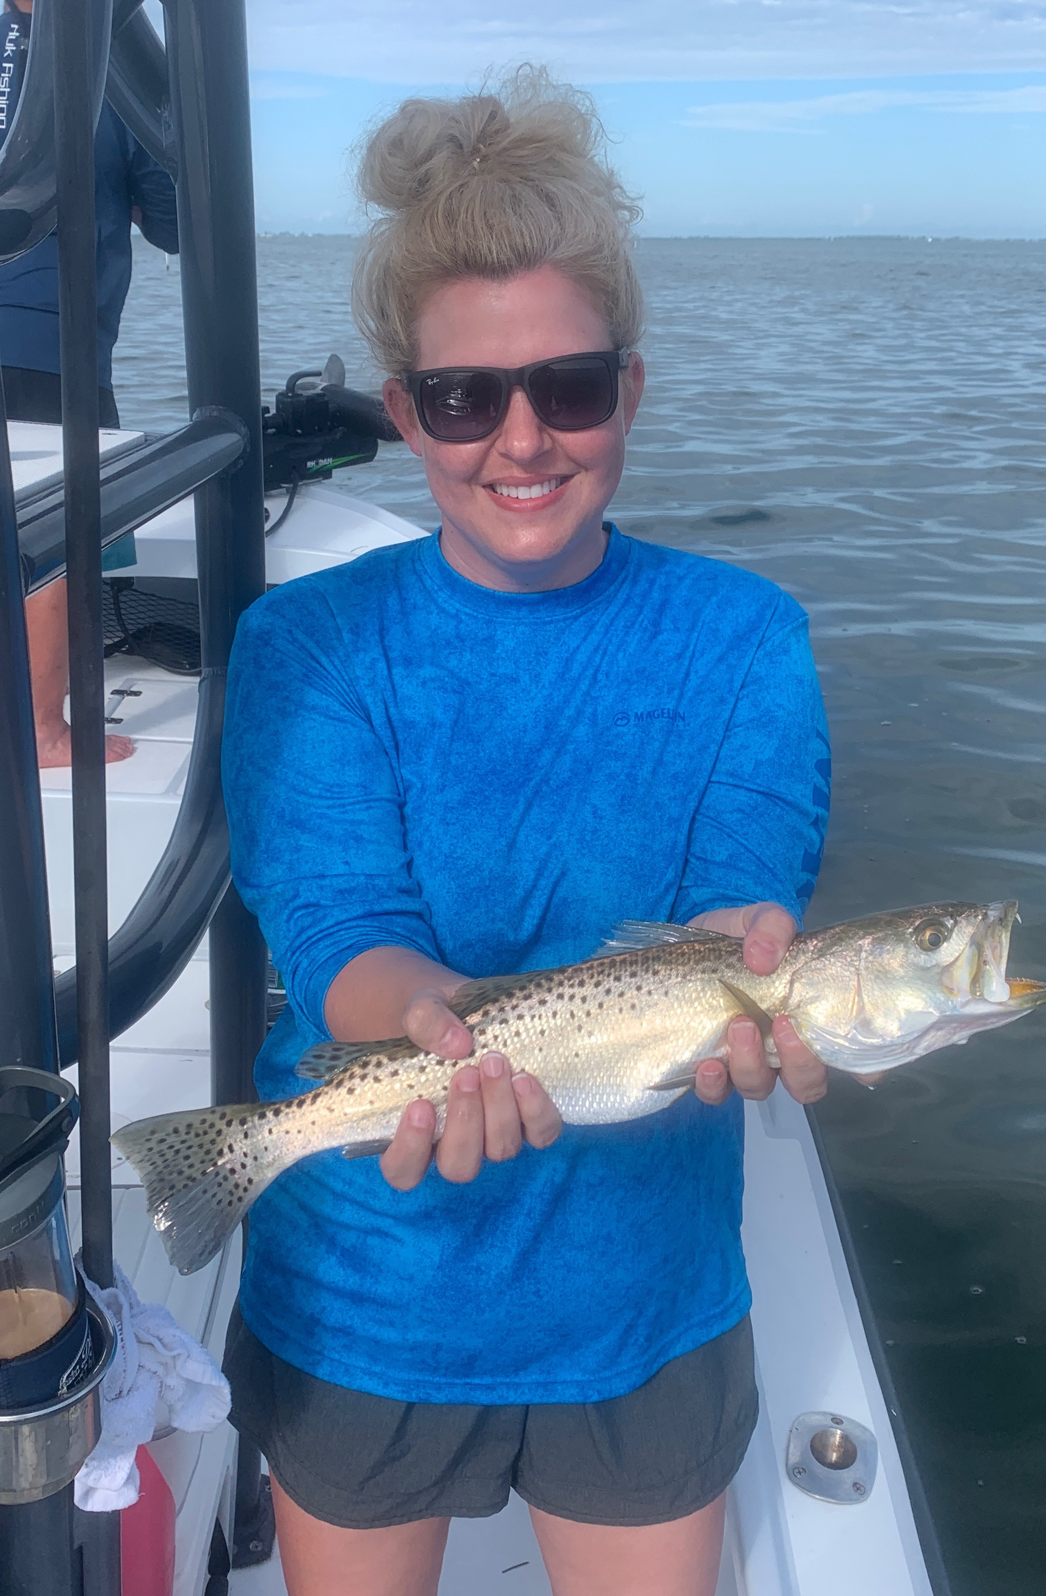

Experience the recovery

Pic: The return of healthy trout making everyone smile

Some of the most rewarding trips as a guide come while intruding new clients to our fishery. Often times its kids or even people who have just never had the opportunity to get out in our amazing back yard. With our waters being as clear, pristine and full of life as I can remember options are endless. Its a great feeling to show off our healthy fishery once again.

The improvement in the management of Lake Okeechobee has been a major factor in the recovery of our fishery over the past few years. Having a South Florida Water Management District that has more than just farming interests in mind has slowed the flow of polluted water from the lake. Clean clear water in the sound has allowed many of the grass flats that are the life of our estuary to gradually recover. Keeping lake levels low during our dry winter months so more water can be stored during our rainy season has been the difference.

The rebound of our trout fishery is a big tell tail sign of the recovery being in full swing . For more than a year after our water woes of roughly 3 years ago we simply just did not see any trout. Trout are one of our more fragile species of fish and were decimated by poor water quality. Trout have become one of our goto species with massive amounts of them throughout the sound once again. These fish are one of the species that flourish when our grass flats are healthy. Being able to catch trout after trout is heart warming.

If you have not had a chance to get out on the water recently now is the time to do it. The next few months are generally the slowest times out on the water with very little boat traffic. Even if your not fishing just getting out to see all the wildlife is a testament to how quickly mother nature can repair its self with better water management. Water is our biggest resource and keeping it healthy should be our number one priority.

