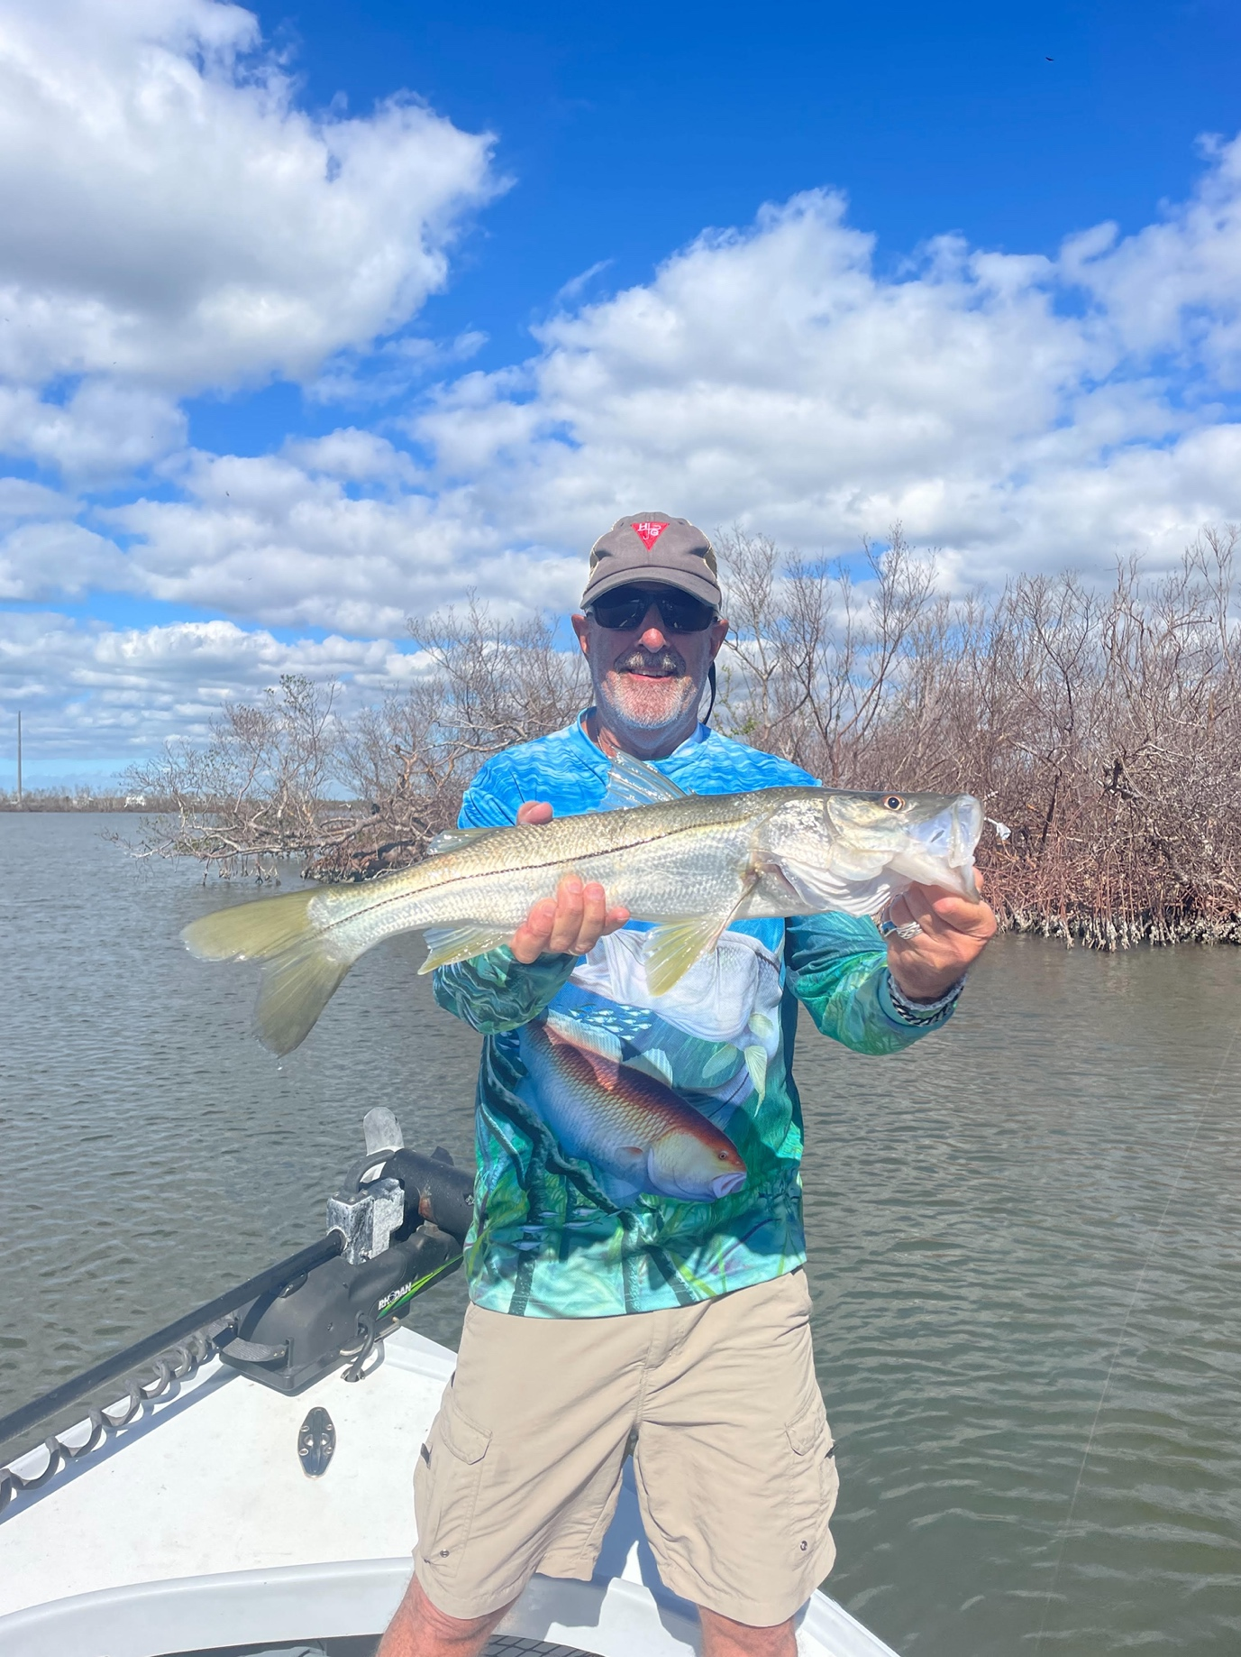

Cold water tactic’s

Pic: Calm afternoons are the perfect time for tripletail fishing

Big swings in our water temperature due to cold fronts over the past month have called for switching fishing techniques to stay on the fish. During these almost weekly drastic drops shrimp fishing has been the most productive method with sheepshead and snook feeding well. During the warm up its been back to shiner fishing with equally good results.

Surprisingly enough even during periods of water temperatures in the high 50’s live shrimp on a jig head caught snook. Fishing deeper water channels in and around the passes with good tide flow we had amazing success on snook when I thought the water was just too cold for them to bite. As the water began to clear up after the winds laid down trout also became part of the days catch in these same places.

Chunks of fresh shrimp threaded on the same jig head caught lots of sheepshead when fishing around docks and pilings in these same area’s. With so many broken docks and piers from the storm sheepshead have even more places to graze on barnacles. Although we are not quite to the best sheepshead fishing of the year which usually occurs in February this action continues to improve with each cold front.

As the water temperatures gradually creep back into the mid 60’s I’ve been catching shiners on the causeway bridges and having some wide open trips fishing for snook and trout. After cold days these fish are just plain hungry and jump on these live bait fish offerings. Mangrove creeks along with deeper holes in the way back woods have been loaded with fish. Although most of these snook are in the 20-25 inch range the action has been non stop.

In the few days before the big last cold front I got to enjoy some calm sunny weather which immediately had me thinking tripletail. Heading out on my skiff during the afternoon with a few dozen live shrimp we had one of the better tripletail trips I can remember in recent years. Out in roughly 20ft of water between Sanibel and Ft Myers beach we hooked fish after fish with the average size being around 10 pounds. Once we got the depth dialed in we located fish after fish on stone crab buoy’s . When it comes to eating fish it just does not get any better for me than fresh caught tripletail cooked on the wood grill.

Over the past few months the drop in business has made for a tough year. Usually this time of year we are in wide open season and fishing guides are fully booked. Post hurricane Ian many of my regular clients simply have no accommodations available. I’m experiencing at least a 50% drop in business while many other guides with no place to pick up clients are totally out of business. If your thinking about taking a charter unlike years past I still have openings and would greatly appreciate the business. The water is amazingly clear and the lack of boats on the water puts very little pressure on the fish making for a great time to get out.

