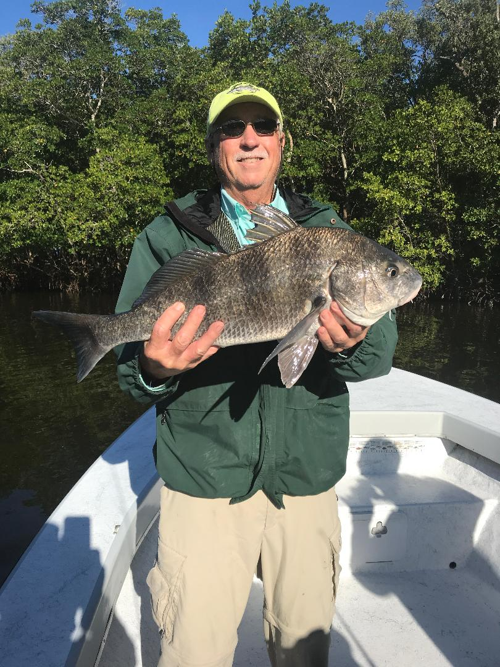

Cold front options

Pic: Gary Biltgen with a Black Drum caught while fishing with Capt Matt Mitchell

Last weeks cold front was the strongest so far this winter. Wind, rain and much cooler morning temperatures than we are used to kept even the most die hard anglers off the water for a few days until conditions improved. As usual getting back on the water after a major temperature drop its feels like your starting over. Fishing started out a little slow which was expected but after just a few days rebounded.

Finding bait is always the first challenge after a major cool down. Every winter we wait for a strong enough cold front to push the bait to the warmer less fluctuating deep water of the causeway bridges. The deep water around the causeway bridge pilings will soon be the go to bait spot all winter but as of now shiners have been very scattered with either lots of smaller ones coming from out along the beaches or the bigger stuff though not in huge numbers being caught while chumming out on the flats.

Returning to fishing after a cold front bringing live shrimp is always a good choice, its not only a back up of your don’t locate shiners just some days its the better bait. In the first few days following the cold front I caught a wide variety of species on the shrimp while often could not even get a bite on a shiner until later in the day when water temperatures gradually warmed up. During the coldest period of the day I like to fish low and slow by putting a live shrimp on a 1/4oz jig head to not only slow it down but to pin it to the bottom. Some days during cold periods this will draw a strike when nothing else does.

A live shrimp shrimp on a jig head also works well when thrown in fast moving current and allowed to sweep by the structure. All winter long this is a great way to fish all our local passes. On the first few days after the cold front when I struggled to find my clients any kind of decent fishing action this shrimp on a jig head method kept the rods bent. The variety of fish we caught on live shrimp was crazy, when you found the right rip or eddy in the pass we caught snook, redfish, black drum, snapper, sheepshead and grouper, Basically everything that swims in our waters eats shrimp.

