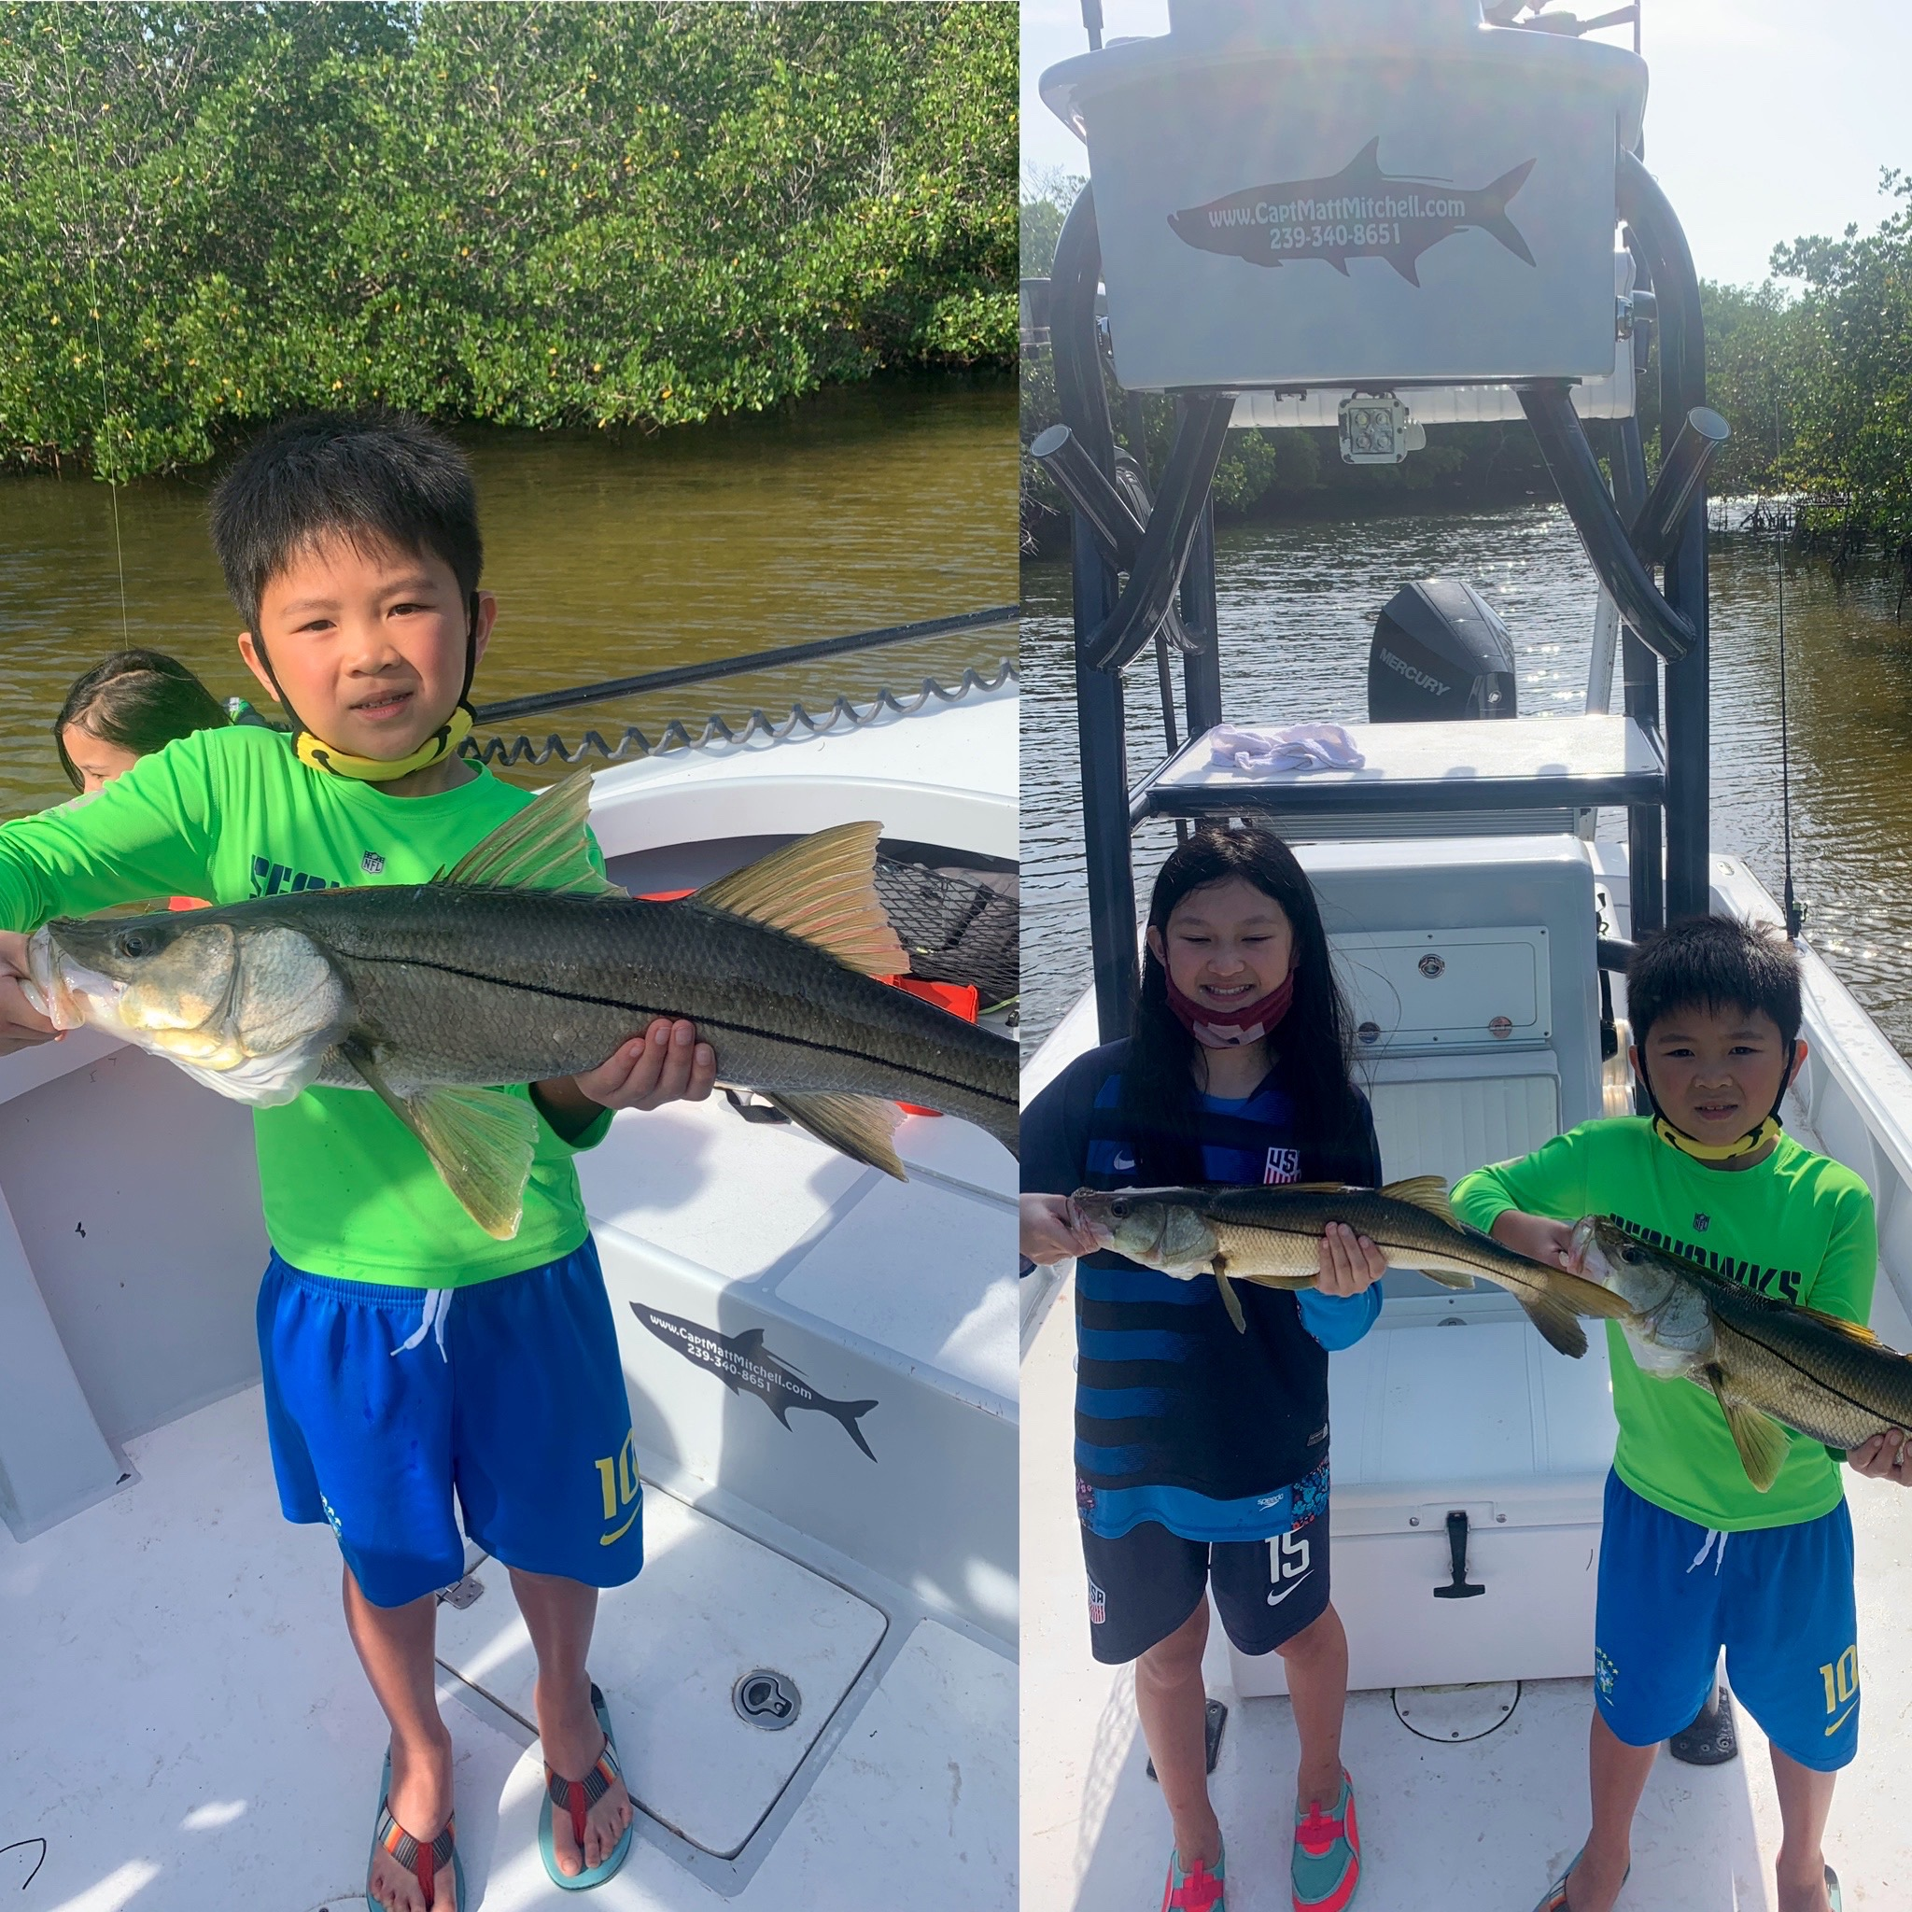

Pic: Reagan and Jack got in on incredible snook action this week while fishing with Capt Matt Mitchell

Change of season, change gears.

I’m often asked by clients what is my favorite time of year to fish. Without a doubt both Spring and Fall offer the most variety along with Tarpon fishing. Seasons in south Florida are not as defined as it northern regions. Early or late cold fronts along with heat waves make that line of when is best much more fuzzy.

Our best fishing here happens when our water temperature creeps up into the mid 70’s. Last year this happened by mid March though most years this does not happen till mid April. We experienced a early Spring along with some of the most amazing Tarpon fishing I can remember.

This same thing holds true in the Fall. The arrival of our first strong cold front that brings the water temperature down to below 70 degree’s brings a end to tarpon fishing. This usually happens around Thanksgiving though some years its been as late as early January.

With most of our Tarpon dates sold well in advance I usually tell clients to book in May or June for your best chance. With well made plans there is nothing worse than having having clients show up early April after a late cold front are there are simply no tarpon here to catch. Anymore when I schedule tarpon trips I start May 1st. If the tarpon show up early I offer it to my clients that are already booked along with locals I have on tarpon standby.

Fish have no calendar and move according to water temperatures. No matter how long you have had that fishing trip booked in advance mother nature can be very cruel. Another thing to keep in mind when booking that fishing trip is weather. Clients often ask what the weather will be like weeks ahead. Even with all the advances in meteorology here in Florida its hard to tell what even tomorrows weather will be.

If you plan on that bucket list tarpon trip don’t put all your efforts into a single trip. If you can go twice or more spread the days out over the week your here. This almost insures you at least one decent weather day.

The arrival of of our migratory Tarpon will always be my favorite time of year. Switching gears and going on that daily hunt for the Silver King is what makes our area second to non. The huge influx of Tarpon we see annually is the most incredible time of year for me to be on the water.

Back to that earlier question of when is the best time of year to fish: “Anytime you can!”

