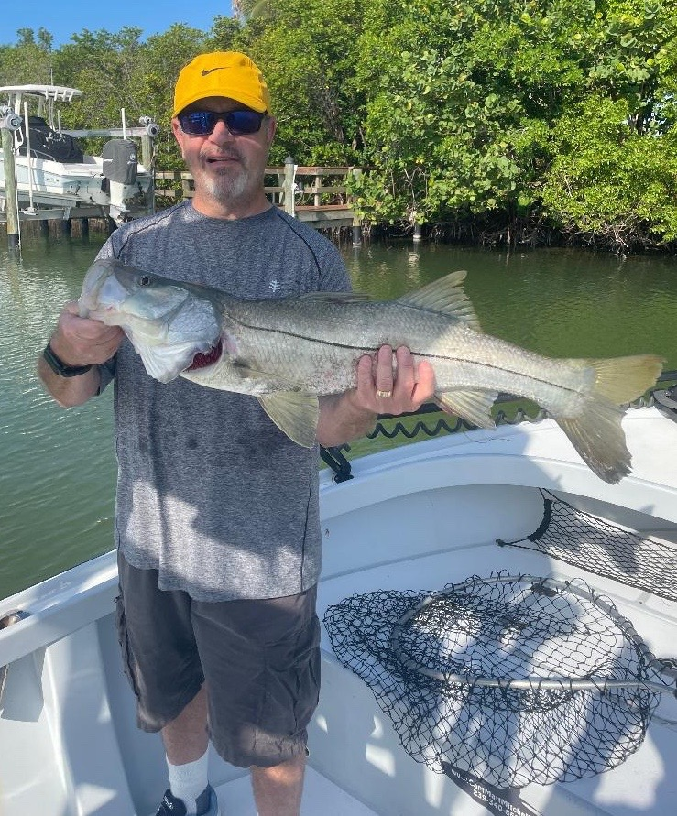

Change of Focus

Pic: Brian from Ft Lauderdale with a quality pass Snook caught this week with Capt Matt Mitchell

With tarpon fishing slowly winding down as water temperatures get up into the upper 80’s my trips this week became more family oriented. Warmer summer waters can make catching shiners more of challenge though the pass bite is getting stronger on both pinfish and grunts. Look for the cooler water to be both near the passes and out on the beaches.

For non-stop action the passes where hard to beat with our summer time snook bite in full swing. With Blind pass almost completely closed up the lack of tide has slowed down the once almost guaranteed non-stop snook bite here. Hopefully there are plans to dredge this pass in the near future as it’s a much needed flush point of the middle sound and really helps with overall water quality in the bay. As in years past the closing of this pass is partly the result of a Captiva beach re nourishment. Prevailing north winds all winter shift this sand south and quickly grow this sandbar closing up this small pass.

Both Redfish and Captiva passes have been the better choice for snook action as the tide is much stronger and more predictable. Look for snags, blow downs, jetties and tide eddies to locate lots of snook. With the water so clear in the northern sound it’s been possible most days to sight fish these laid up fish. Both free lined shiners and pinfish on a jig head kept the rods bent.

Many of my family charters this time of year like to include a fresh fish dinner. With our mangrove snapper bite being as good as it gets in the sound a quality fresh fish dinner has come relatively easy. These tasty abundant food fish are being caught all through the sound and passes with small pinfish, live shrimp and shiners all working well. The lighter the gear you can use the more you will fool these leader shy fish. Start with a 1/0 light wire hook and then at least 3ft of 15-20# fluorocarbon leader. My best snapper
action this past week came while fishing around deeper docks in the southern sound and Matlacha pass.

Boat traffic out on the water has noticeably quieted down over the past few weeks as our seasonal residents have headed home. It sure feels good to have lots of options and very few other anglers to compete with. Getting out early and trying to beat the heat has become a necessity as our summer heat index has been creeping into the 100’s daily.
I cannot say enough about drinking lots of water along with Electro-light loaded drinks to stay hydrated during this extreme heat.

