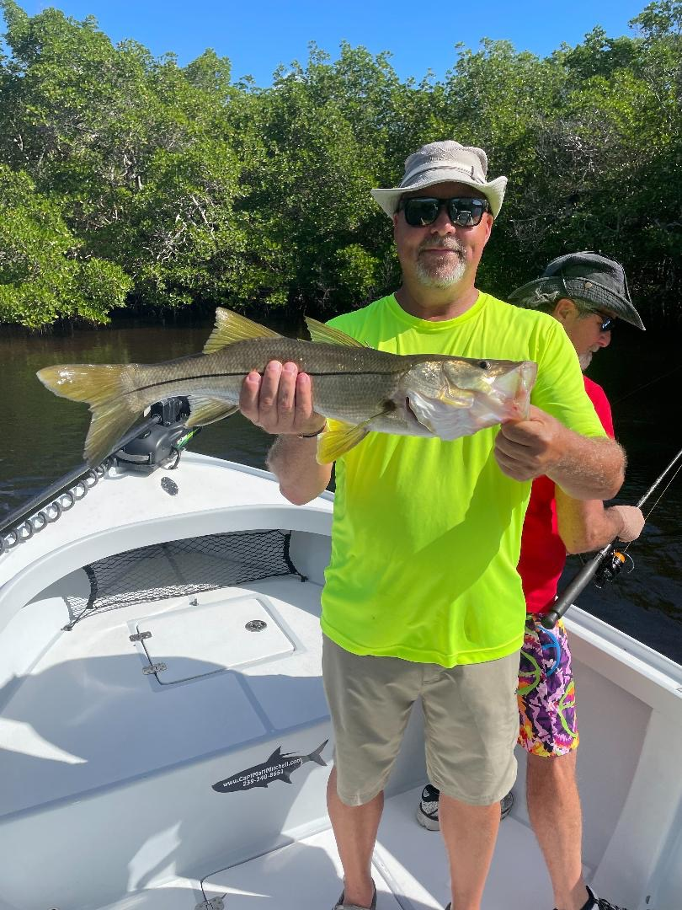

Pic: Steve from Illinois got to catch snook on his 60th Birthday

Change it up after the front

An earlier than usual cold front blew us off the water for 3 solid days this week. Wind gusts over 30mph and even some rain meant cancelled charters along with a few days off. Most years we don’t experience such a dramatic cool down until roughly around Thanksgiving. Once this first cold front has opened the gate this can be an almost weekly thing. Timing your fishing trips becomes really important as the closer the approaching front the better the bite gets. During the front and for a day or so after we are get blown out. Then after the front has passed the bite slows then gradually improves as so do conditions. That will be the cycle all winter long.

When heading back out on the water after the front there will certainly be some changes with the most significant being locating bait after such a major blow and cool down. The normal grass flats and spots out on the beach we have been catching shiners on for the last few months will be really stirred up and the bait spread out if not gone. As water temperature drops these baits often head to the the bridges in mass numbers. All winter this deeper fast moving water will be where the shiners are unless it gets really cold or warm enough for them to go back on the flats..

One option I always like to have after a cold front is the insurance of having live shrimp. During the first few days of the high pressure associated with the passing of a front the bite can be tough. Fish will eat a shrimp when they just won’t eat anything else. Live shrimp fished on or close to the bottom on a 1/4oz jig head will get it done when nothing else will. A fast moving free-lined shiner may not even get touched.

This cold front should bring us roughly a 10 degree drop in water temperature that will fire up the fishing once conditions level out. Look for lots more snook to have made the move from the passes and the beaches to the transition areas. Oyster bars and mangrove points in the middle sounds are the stopping off places as these fish make the move towards their winter haunts. Mangrove creek fishing for both snook and redfish will light up as many of these small deeper channels are not as affected and churned up by bad weather. Trout that have been out on the open flats will have also found shelter and better cleaner water conditions in the deeper sheltered small mangrove bays and channels.

Although it will be several days until the wave action out along the beaches relaxes once things calm anglers will be greeted with the south bound bait migration in full swing. Mackerel and Bonita fishing will fire up. With water temperature now in the mid 70’s we may still get one last chance at a tarpon before the spring. Finding schools of bait are the key to these beach fisheries

