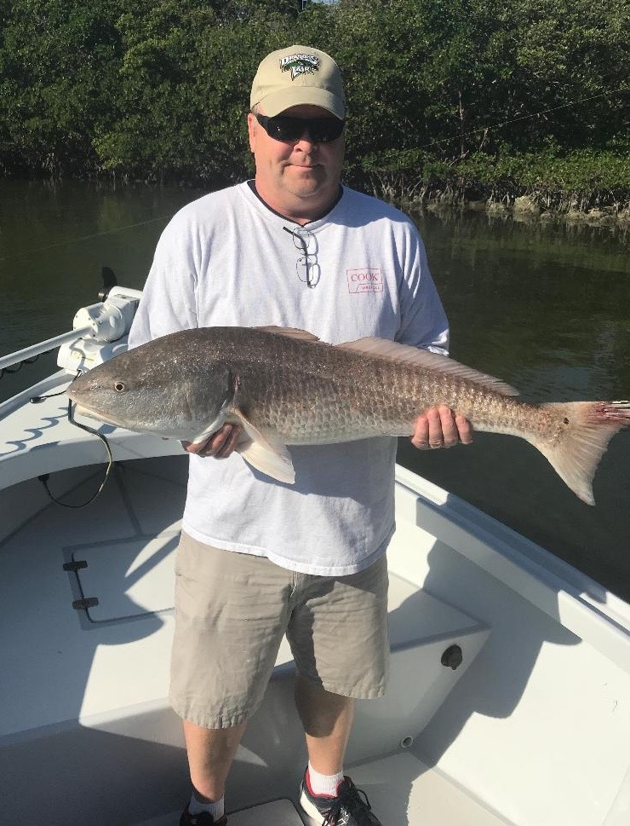

Pic: Kurt from Indiana with a 38 inch redfish caught and released with Capt Matt Mitchell this week

Big Redfish in the passes

Another week of cooler mornings brought great fishing action and was enjoyed by everyone this week. Big redfish and Snook kept clients smiling as the bite at times could only be described as stupid. I don’t ever remember such a long period of catching at least one slot sized Snook on just about every trip. Action on redfish has been either really big fish or small fish with really nothing in-between. During calm winds or periods of east wind the action out on the beaches is non stop too with lots of Spanish Mackerel, ladyfish and Jacks keeping the rods bent. We do still have tarpon and lots of sharks out on the beaches in the same places as the feeding Mackerel its just a matter of getting a calm day.

Getting out Gulf side and running crab pots for Tripletail has been very productive too. Most of these tripletail are on the small side of the new 18 inch minimum though if you put your time you will find some keepers. I have had a few reports of a few real monsters close to the magical 20 pound mark out a little deeper around the Belton Johnson reef and Paces Place. With so many stone crab pots out its just a matter of running and looking until you see one sat under a crab buoy. Live shrimp are hard to beat for bait and depending on your skill level of casting you can either free line the shrimp or put it under a float. A trolling motor is an amazing tool for this fishing as these fish especially the larger ones can be very spooky at times.

I’m still catching shiners though I have moved away from throwing on the causeway and the beaches and got back to chumming them on shallow grass flats to get the medium to larger sized baits. Seems most of the bait on the bridges and beaches right now is on the smaller side. What this small bait lacks in size it makes up for in sheer numbers as often it only takes one cast to have enough for the days fishing. I’ve also been taking hand picked shrimp as some days the better bite on Redfish has come bouncing a live shrimp on a jig head.

While out with long time returning clients from Indiana this week we had one of the best days fishing I have experienced in months. We lost count of the big redfish we landed all over 30 inches long also catching lots of Snook with two of them over 30 inches. We even managed three bonus unexpected keeper Black drum up to 22 inches. Hand picked shrimp rigged on a 1/4oz jig head fished in the passes during the last few hours of the falling tide proved to be the set up for some of the craziest action I can remember in a long time. Double and even triple hook ups on all over the slot sized redfish came at times as quickly as you could get a bait in. Returning later in the day during the low incoming tide the bite was done. The big Redfish of the week on my boat measured 38 inches though I had reports from other Captains with redfish as big as 48 inches caught in all our local passes during the outgoing tide.
Attachments area

