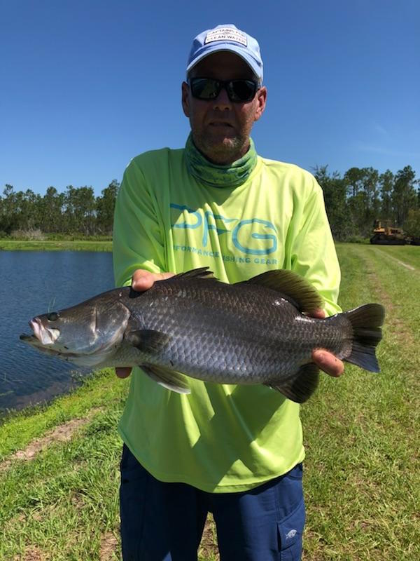

Barramundi Fishing in Florida

Picture: A Barramundi caught in St Cloud Florida while fishing at Osceola Outdoor Adventures.

Barramundi are a close relative of the Snook and native to Northern Australia they can grow to over hundred pounds and have been a bucket list fish for me for a long time. A few months ago I came across a place in St Cloud FL that has Barramundi stocked ponds and offers anglers a chance to catch these very cool fish without traveling thousands of miles. This is the only place in the U.S in fact the northern hemisphere. you can catch one. Without knowing what to expect I pulled out the credit card and booked the trip online.

After a spending the night in Orlando it was about a hour drive. Upon arrival we met the owners Kim and her husband Byron on this large spring fed property that for several generations had farm raised fresh water aquarium fish. The story goes a Australian company went into business with them to farm raise Barramundi for food until the freeze of 2010 wiped it all out. At the time of the freeze they had fish in these ponds as large as 22 pounds..

I had never been on a fishing trip anything like this before. Kim loaded us on a decked out golf cart set up for fishing and away we went around a man made lake. It did a little while to get these fish dialled in on what and how they wanted to eat. Slow bouncing a chartreuse soft plastic jig with a barbless hook the action started. These fish suck a bait down just like a snook and make the close to the same powerful strong runs and jumps. On closer inspection they not only have resemblance to a snook but a mouth and gill plate rackers a lot like a tripletail then large scales like a tarpon.

The 4000 Barramundi they have now have only been in this pond since November when Byron and Kim went back into the Barramundi business for themselves. These fish were purchased and released as one pound fish. In the seven months they have had them they have already grown them to an impressive average size of 3-5 pounds with some as large as 7 pounds. Their plan is to keep this 1st pond as a the larger trophy fishery as
they are now starting another pond as a sustainable fish farm. Barramundi is excellent to eat and very close to eating Snook.

This unconventional fishing from the bank was a blast with us hooking more fish in a few hours than I can count. Many of the fish throw the barbless hook when they jump and keeping a tight line on them was key to staying hooked up. Being close to Orlando I had no idea what to expect and had my fingers crossed this would not be like a theme park of fishing. Kim and Byron have this operation set up really well with only one group fishing at a time. I’m already looking forward to taking another trip up and enjoying their pets as they continue to grow maybe next time on a fly rod.

