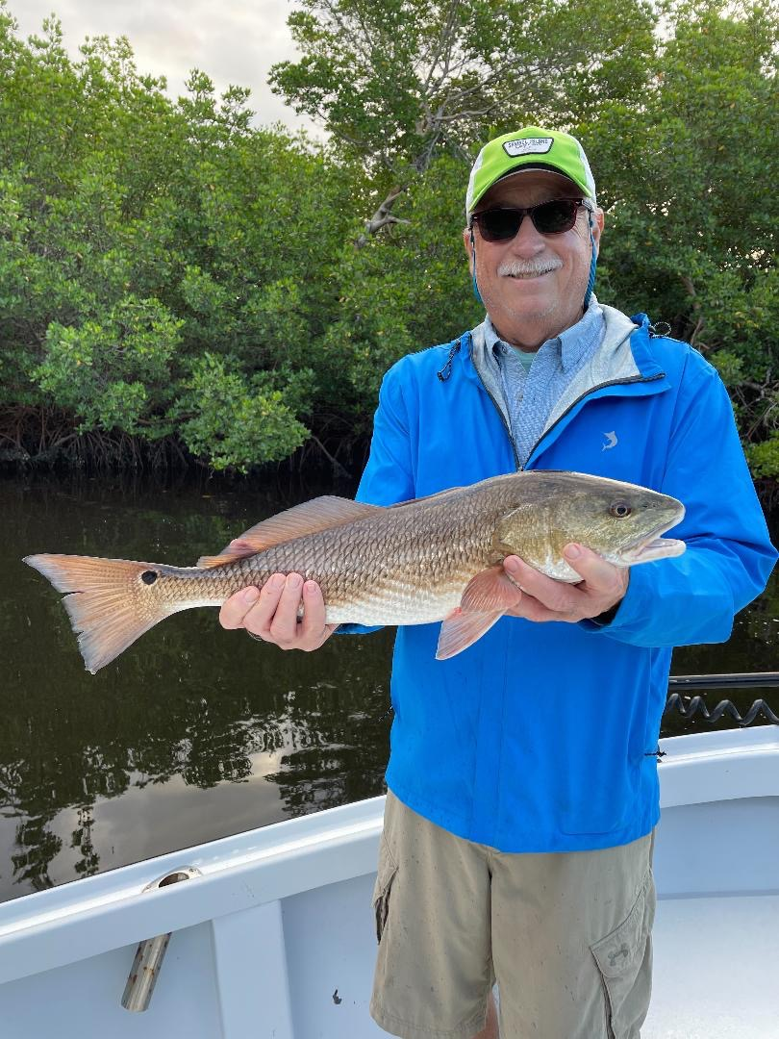

Bait and more bait

Pic: Gary Biltgen with a quality redfish caught while fishing with Capt Matt Mitchell

From the beaches to the sound and everywhere in between the amount of baitfish we are seeing is amazing. This makes catching bait easy but even more importantly it’s a major sign of our currently heathy waters. One of the things that makes Pine Island Sound such a incredible fishery is the amount of bait it produces. With so much food here its support lots of healthy game fish making it one of the best inshore fisheries in the state.

Fishing during the lower morning tide periods this week was amazing. Fast moving water in and around the passes along with mangrove creek systems all proved to be the right call to catch lots of fish. Snook remained the main target though we did catch some redfish and trout in the mix too. Our mangrove snapper bite is slowly winding down as it does this time of year. Look for more and more snook to make the way to the back country over the next few weeks.

One of my favourite things to do with so much bait in the live well is to live chum. A whiffle ball bat or aka chum bat is standard equipment on most guide boats. I put a dozen or so shiners in the bat at a time then give it a shake to slightly stun the bait before pitching it to a shoreline.
This quickly tells you if there are feeding fish in the area and also draws the fish out from the mangroves. When the fish fire off its just a matter of making a quick well-placed cast to the pop of a surface feeding fish and the bite is often as quick as you can close the bail.

When rigging to shiner fish the simpler the better. I tie a line-to-line knot using 3 to 4ft of 25# or 30# test fluorocarbon leader. To that I tie a loop knot to a 1/0 or 2/0 hook depending on the size of the bait. Hook the shiner through the cartilage between the nostril and the eye. The lighter the set up the more natural the bait can move and the more strikes you will get.

With the bait migration in full swing the beaches are offering anglers a great mixed bag of species. As our water temperature is now in the magical 70’s, look for more and more Spanish mackerel, King Mackerel and Bonita to be surface feeding on these bait schools. This visual bite is easy fun fishing and can be nonstop when throwing spoons and live baits. With Stone crab season now in full swing there are plenty of crab pots out there making Tripetail a great option too.

