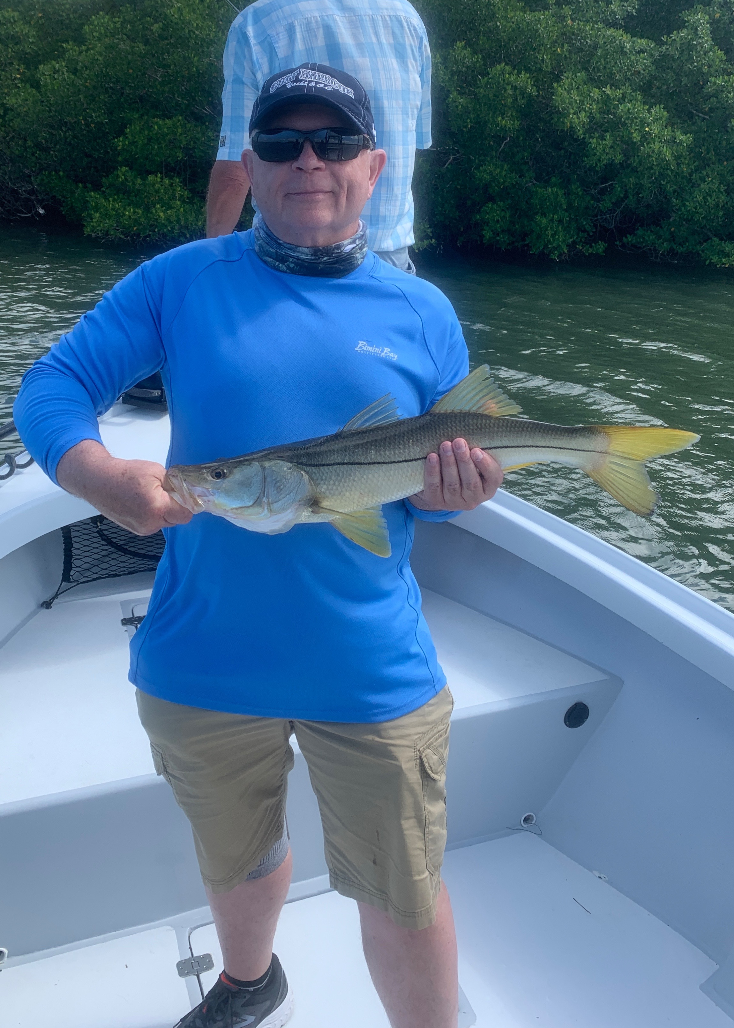

Pic: Longtime client Kieth Silar with a windy day Plan B Snook caught with Capt Matt Mitchell this week

Back to my roots

After a solid week of windy conditions things finally let up for the weekend. Fishing in the wind is not always a bad thing although it does make locating tarpon next to impossible. All it took was one calm day and the tarpon reappeared throughout the sound. Calm days are what we all dream of for tarpon fishing as these fish spend much more time up by the surface when its slick.

The eastern side of the sound held more tarpon than I have seen in a week as the winds relaxed. On a trip over the weekend I had very low expectations after days of bad weather. Riding through a favorite area in the middle sound I figured I’d give it a quick look before going to plan B Snook fishing. Within 5 minutes we were greeted with rolling and free jumping fish. Setting up within 15 minutes we jumped a tarpon on a cut mullet. The longer we sat there the more fish appeared although they did not cooperate I can’t wait to get back on them tomorrow.

Smooth water creates the perfect conditions to take out my new 16ft Silver King skiff. When I originally started guiding over 20 years ago it was on a very similar 17ft flats boat. More than 10 years ago I switched to a 22ft tower boat to accommodate larger groups and be able to fish more comfortably in choppy conditions. Although I love the classic 1969 Aquasport there is a lot to be said about the stealth of a small boat. Silently moving on a push pole allows you to get much closer to the fish. This return to my roots is a great option to have and I’m very excited about specific situations this little boat will excel in.

I plan on using this boat for working mangrove shorelines with artificial baits, stalking tarpon on the flats and taking my fly fishing enthusiasts.
The smaller boat seems to put you closer to nature and creates a more peaceful atmosphere. Being able to sight fish while push poling for a variety of species is another fishing experience I can now offer my clients.

