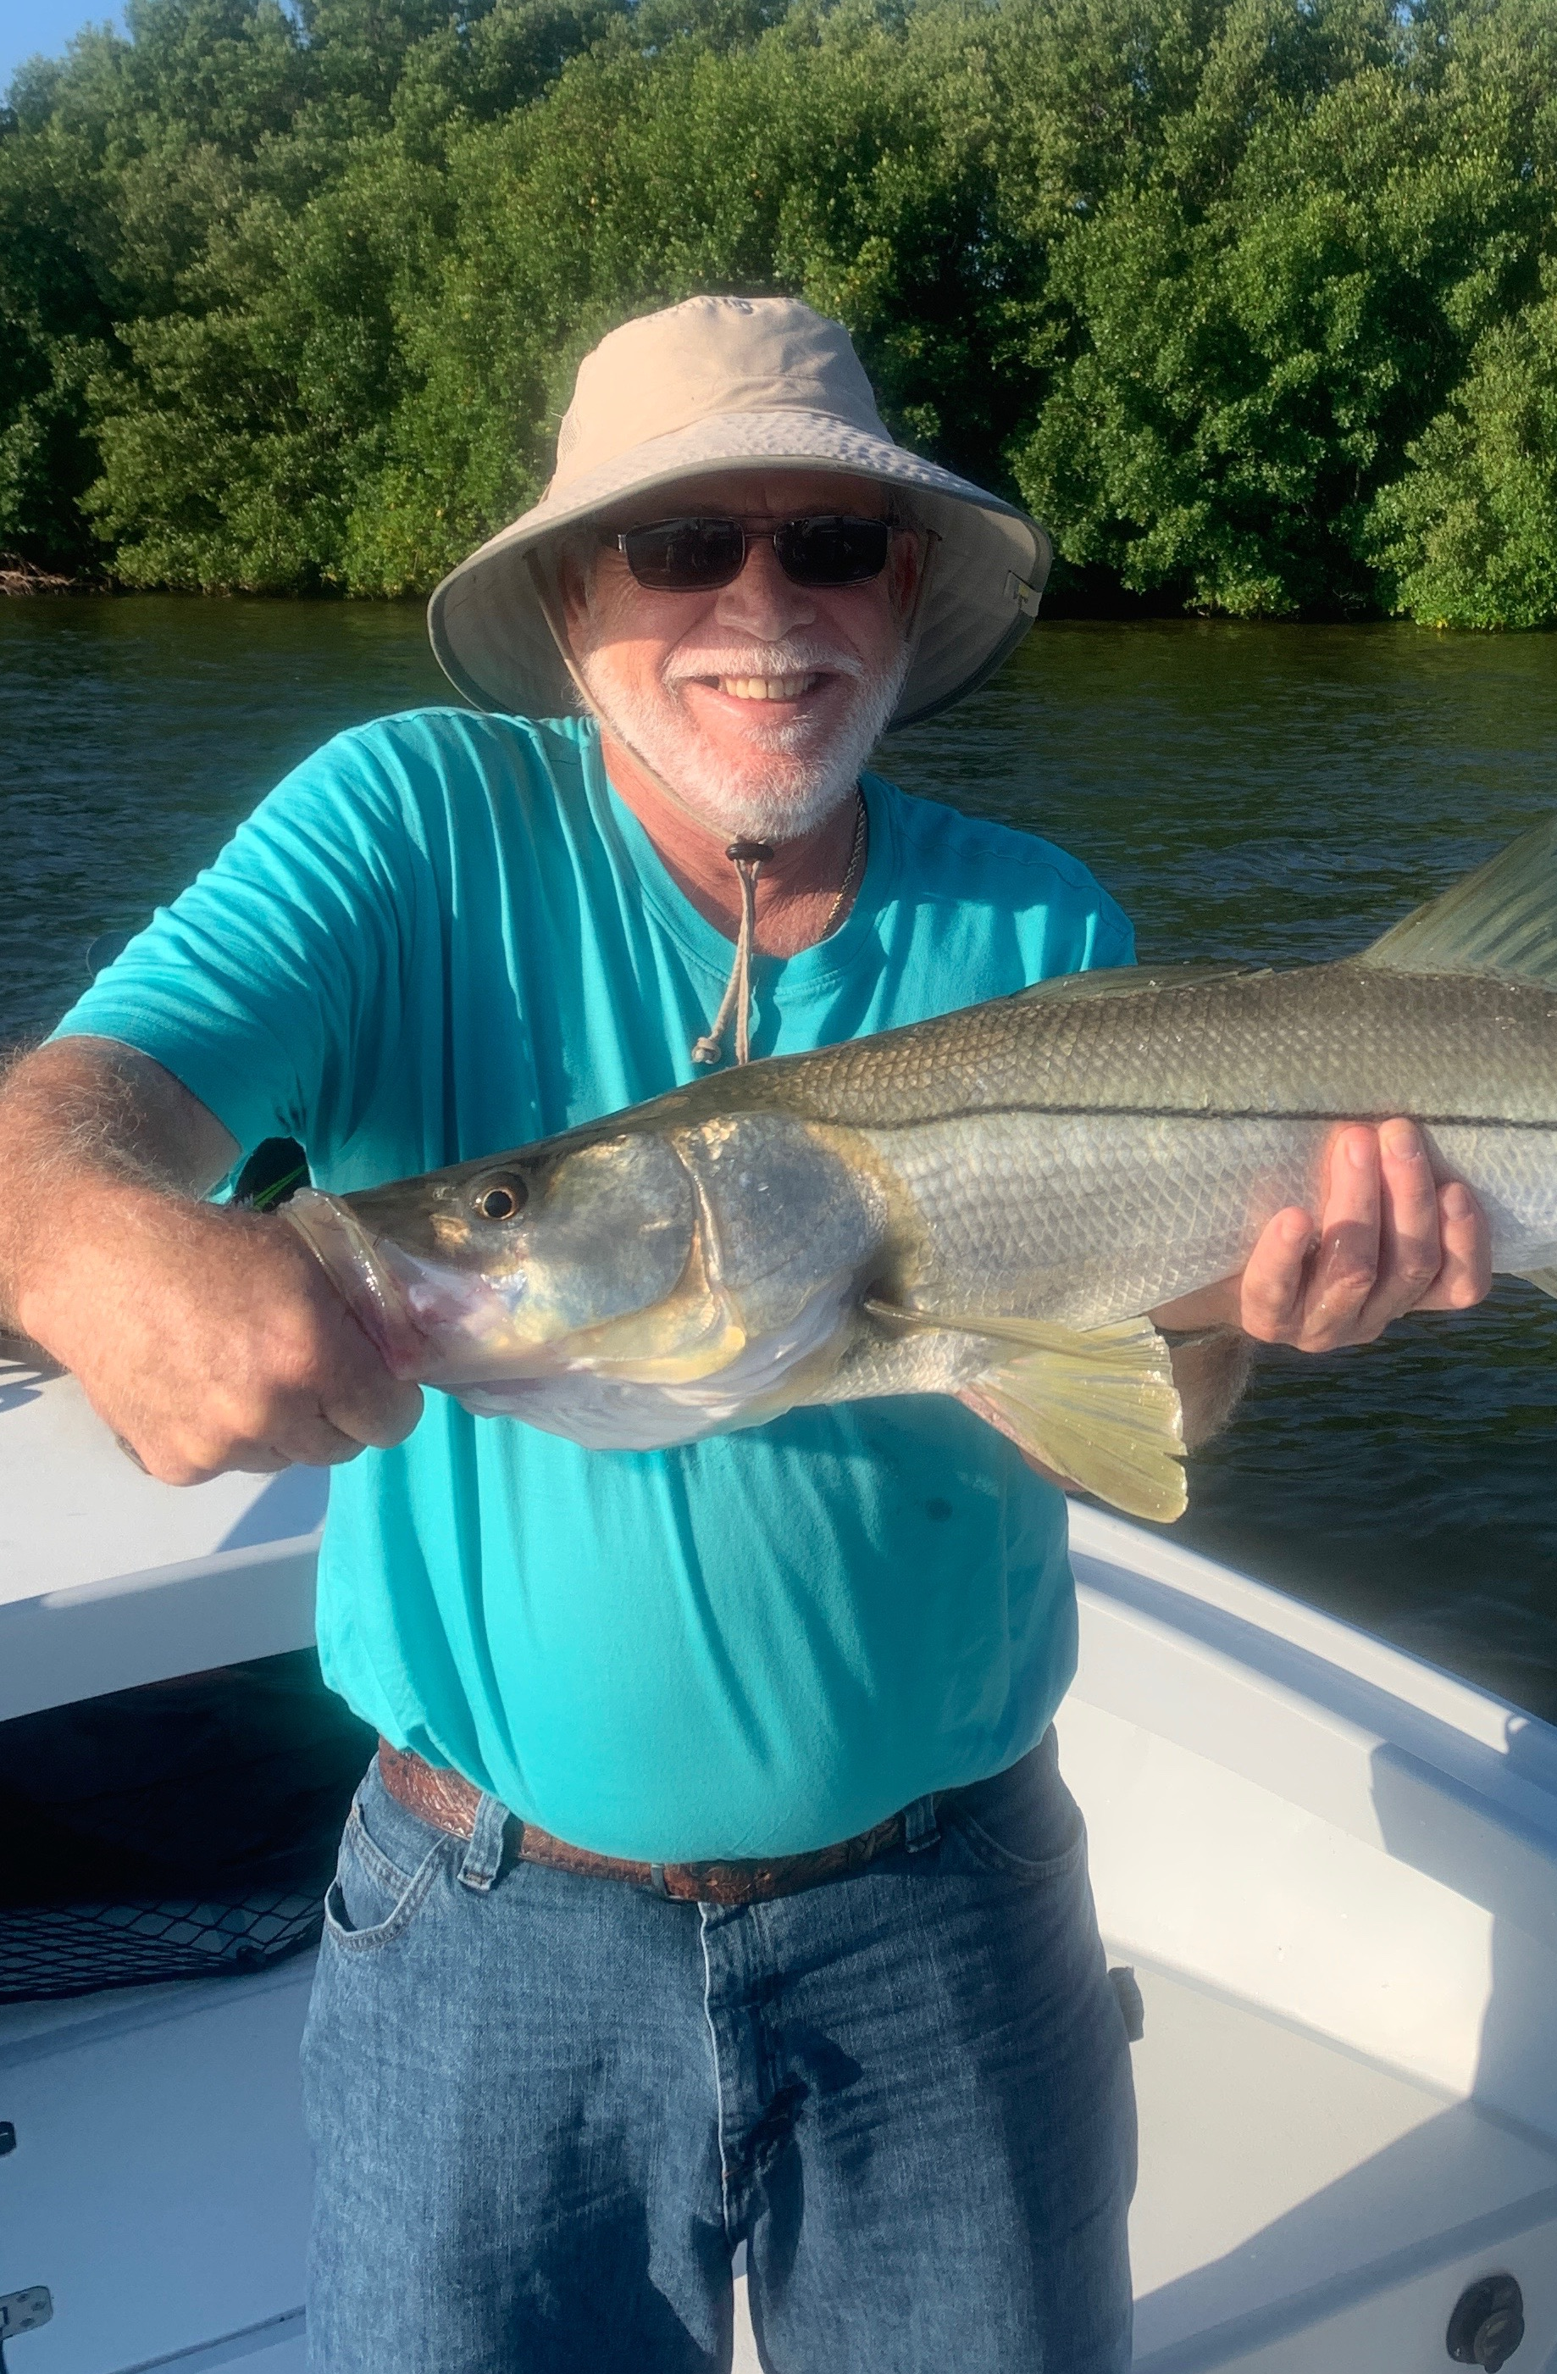

Amazing fall fishing.
Pic: A 33 inch birthday snook for Mr Oden from Arizona caught while fishing with Capt Matt Mitchell

Fall fishing continues to be nothing short of amazing. With so much bait throughout our area fish are feeding hard as they pack on the weight before the arrival winter. Wide open blitz’s of feeding fish out along the beaches are becoming more and more common. In the sound both snook and redfish fishing is also on fire.

With the annual arrival of White pelicans aka snowbirds already starting this is a sure sign that winter is on the way. The change of season no matter how subtle it seems to us has the fish on the hungry and on the move. Out along the beaches huge schools of bait have begun the annual migration south. Mixed in with this bait are the predators that feed on it. Bonita, mackerel, bluefish, sharks and tarpon smash through this seemingly never ending bait buffet. Grass flats in the sound are also covered up with shiners and although the predators are different here its the same thing just on a smaller scale.

Strong gusty northeast winds most of the week gave us some of the lower tides we have seen in a long time. Deeper water channels had the fish stacked up in big numbers. Snook, redfish, trout, jacks and snapper where caught in all in these same area’s. Chumming lots of live shiners in these channels had the fish fired up and eating on the surface. Thees fish always feed on a moving tide so concentrate on shorelines that have wind and tide moving in the same direction.

As the tide got higher I have been switching it up and fishing oyster bars. Picking an oyster bar with the right set up of wind and tide has made all the difference. Even though I caught fish on one bar yesterday it certainly has not meant the fish will be there today. Going from bar to bar it only takes a few casts to see if the fish are there. We have oyster bars throughout the whole sound so finding the right one is just a matter of moving around. Seeing mullet working the oyster bar is a great sign that your in the right place.

Fall brings us some of the most diverse and exciting fishing we have all year. Not only do we have are regular inshore species we also have all the pelagic species moving down the coast. Options are almost endless. When conditions are right being able to bounce between the bay and the beach will bring a crazy amount of variety.

